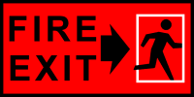

Resident Safety in TANG HALL

Preparation for emergency:
• Learn to recognize the fire alarm signal
• Locate the exit door closest to your room
• Become familiar with an alternate/secondary exit and walk this route
• Always leave the building when you hear the alarm

NEVER USE THE ELEVATOR

Report Safety Hazards to the House Manager, or House Masters
• Remove/report any items blocking corridors, stairways, or exit doors; nothing can
be kept in hallways per Cambridge Fire Department Order.
- Keep exit stairway doors closed at all times
- Don’t hang anything from sprinkler heads
- Don’t cover smoke detectors or fire alarms
- Only furniture treated to meet California Technical Bulletin 133 can be used in lounges

General Housekeeping
- Large items left in hallways will be removed by the House Manager
- If you see any rodents, pests, or signs of them, contact the House Manager to arrange for pest control
- Per MIT’s student handbook, “The possession, manufacture, storage, or use of dangerous or flammable chemicals, explosives, or ammunition in the Residence Halls is forbidden.”
- Please notify your House Manager if you receive or see any packages being delivered to a residence hall with any of these danger warnings.
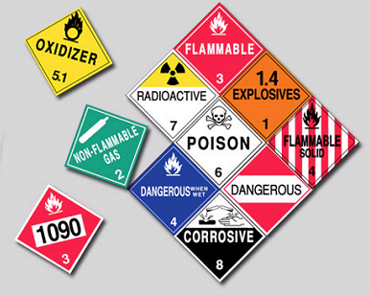

Procedure for Emergency Evacuations:
• If you see a fire, activate the alarm system
- Evacuate immediately if the fire alarm sounds
• Upon hearing the alarm, leave your room and close the door
• Alert others as you walk to the closest exit
• Walk quickly to your closest exit door or stairwell
• Proceed to your designated meeting place

In good weather, meet: AROUND THE TENIS COURT
In inclement weather, meet: W85 WESTGATE LOBBY AND/OR BASEMENT LOUNGE W85

