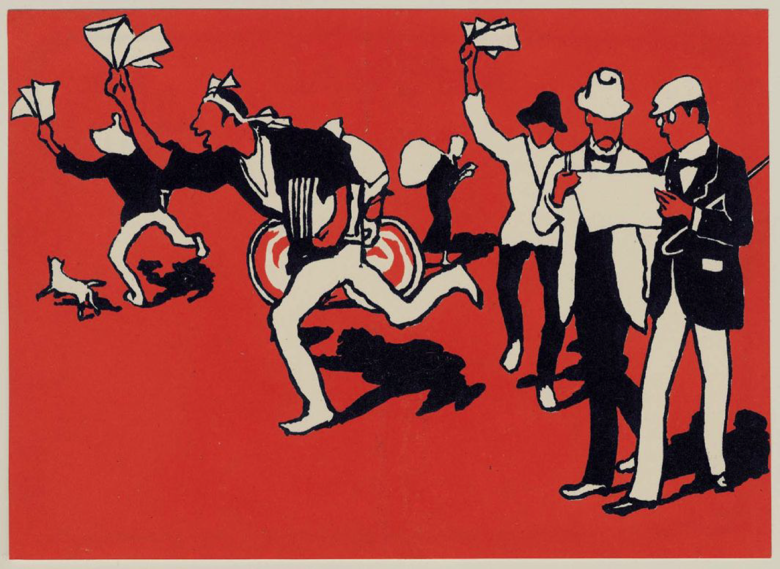

Re-Visualizing Japan:
A Symposium to Honor John W. Dower

Monday, May 17, 2010
Massachusetts Institute of Technology
Building 10 – Room 105

Panel I
10:00 a.m. – 12:00 p.m.

Chair: Harriet Ritvo, MIT

Speakers:
Herbert P. Bix, Binghamton University
“Forty Years of Japanese Studies”

Andrew Gordon, Harvard University
“Revisiting E.H. Norman, Japan, and the Uses of History”

Peter C. Perdue, Yale University
“The Gentle Radical and the History of Japanese Studies”

Lunch Break
12:00 p.m. – 1:00 p.m.

Panel II

1:00 p.m. – 3:00 p.m.

Chair: Philip S. Khoury, MIT

Speakers:

Timothy George, University of Rhode Island,
“Minamata and More: Writing Japan’s Environmental History”

Daqing Yang, George Washington University
"Technology and Empire in Modern Japanese History"

Franziska Seraphim, Boston College
"Teaching Japan's War and its Legacies--Comparatively"

Break
3:00 p.m. – 3:30 p.m.

Panel III
3:30 p.m. – 5:30 p.m.

Chair: Peter C. Perdue, Yale University

Speakers:
Laura Hein, Northwestern University
“Reckoning with War in the Museum: Hijikata Teiichi at the Kamakura Museum of Modern Art”

Shigeru Miyagawa, MIT
“Visualizing Visualizing Cultures”

John W. Dower, MIT
“Reflections”

Reception
5:30 – 6:30 pm

This symposium is sponsored by the MIT History Faculty and the SHASS Dean’s Office.

