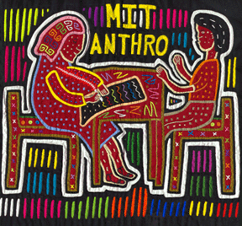

MIT
ANTHROPOLOGY
presents

“Archived Relations: Repression, Rehabilitation and
the Secret Life of Documents”
Chris Kaplonski
Cambridge University UK

This paper examines the rehabilitation of victims of political repression from the 1930s, particularly Buddhist monks, in contemporary Mongolia through archival sources that largely remain outside of public use. These documents and the processes of their creation and recovery help us to learn how the state justified the eradication of religion in the 1930s, and then how it changed its logic during its rehabilitation process in the 1990s. I trace this transformation in logic and the discourses of arrest and rehabilitation by piecing together the case of a lama, Samdan, who was twice arrested as a counter-revolutionary in the 1930s, and then rehabilitated in the 1990s. Dispersed within the opaque structures of the state archives the documents -- the ethnographic artefacts -- take us through the corridors of archives and the logic behind the state policies and show the creation of new forms of knowledge relationships.

Monday, December 1st, 2008
12:30-2pm
16-220

