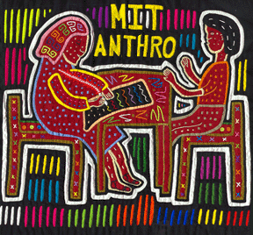

MIT
ANTHROPOLOGY

“Cancer Butch”
Sarah Lochlann Jain
of Stanford University

The academic literature still tends to take Audre Lorde as the primary feminist theorist of breast cancer, and her The Cancer Journals (1980) remains, nearly three decades out, the definitive word on breast cancer and gender theory. This lecture revisits the
cultures and politics of cancer, offering a queer analysis of breast cancer in the U.S.

Tuesday, October 16, 2007
4:15-5:30pm
16-220

