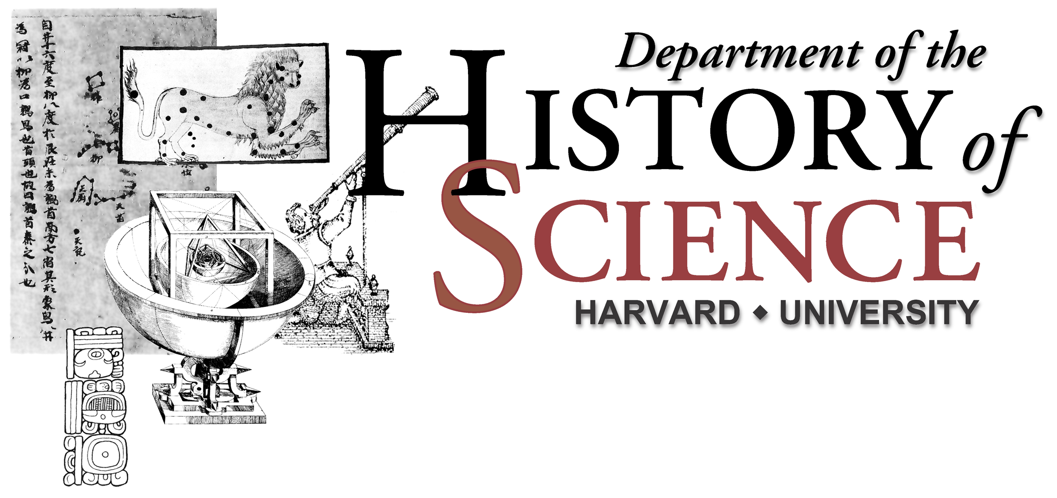

Presenting the Spring 2005 Colloquia

Tuesday March 1, 12:00 pm
Professor Duana Fullwiley (New York University and the Institute for Advanced Study)
“The Bio-logistical Construction of Race: Markering Difference for ‘Minority’ Disease, Health and Markets.”

Tuesday March 8, 4:00pm
Professor Serafina Cuomo (Imperial College, London, and The Institute for Advanced Study)
“Building the House of God: Architects in Late Antiquity”

Tuesday March 22, 4:00pm
Adrian Johns (Associate Professor, Department of History, University of Chicago)
“The Great Oscillation War: Early Broadcasting and the Politics of Popular Experiment”

Tuesday April 26, 4:00pm Science Center Hall D
Professor Evelyn Fox Keller (Professor of the History and Philosophy of Science,STS, MIT)
The Robert and Maurine Rothschild Distinguished Lecture in the History of Science

Tuesday May 3, 4:00pm
Professor David Edgerton (Hans Rausing Professor, Imperial College, London)
“Rethinking the Historiography of Science, the Military and War in the Twentieth Century: Towards a Critique of Academic and Civilian-Centred Accounts”

Tuesday May 10, 4:00pm
Professor Michael Lynch (Department of Science & Technology Studies, Cornell University)
“Credibility and the Administration of Evidence in Forensic Science”

Please check each date for Time and Location in the Science Center
Colloquia will be held on Tuesday starting at 4:00 pm in Room 469
For information please call 617-495-3741

