A Secret Formula, a Rogue Patent, and the Public Understanding of Nerve Gas:
A Curious Incident in the History of Chemical Weapons Research

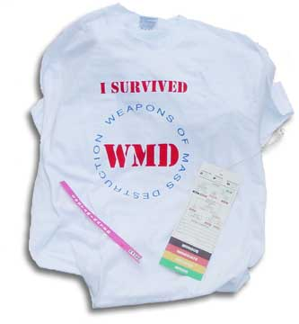
By Brian Balmer
Science & Technology Studies Department,
University College London

Thursday March 10, 2005
12:00-1:30, MIT, E51-165

STS Brown Bag Lunch lecture sponsored by the Program in Science, Technology, and Society

