PR Overall Approval Determination Business Rules / Process
(See Function Module Z_LIST_PR_HDR_APPROVERS for specific code)
QA3 Example Purchase Requisition 15311996 01/26/2005

- Get all the active lines of the PR.
- Line item deletion flag is blank (EBAN-LOEKS)
- Line Item Creation Indicator is not MRP (EBAN-ESTKZ ne ‘B’).

- Get the cutoff limit parameter for approval limits from ZWFVAR table
(ZWFVAR-ZTYPE = ‘PR_HDR_APPR_MIN’).

- Get cost center, line value for each PR lines and total PR value. (Perform get_all_cost_centers)
  - Cost Center determined based on Account Assignment Category value
  - Value of each active line item is calculated
  - Total value of the Purchase Requisition is calculated.

- Get the plant with the highest aggregate PR value. Also for that plant, get the cost center with the highest aggregate PR value. (PERFORM get_hdr_cost_center)
- Determine the plant with the highest value in this PR.
- For such plant, determine the cost center with the highest value.

- Determine dollar approvers pertaining to the cost center from above and qualified for approving 'total' requisition value.
- Get list of positions in the cost center.
- Check if each position has a dollar approval limit. If an assigned approval limit was found get the personnel.
- Stop looking up the organization chart when the approval limit of this position is greater than the Purchase Requisition overall dollar value.

- Determine the highest aggregate cost center value for each plant in the PR. Use these cost centers to find overall approval positions needed for each plant. Note: LED and SED plants could be included in the same Purchase Requisition. Each division (LED and SED) has different VPs. Therefore we need to find all the dollar approvers needed per each plant path in the SAP organization structure.

- Determine dollar approvers pertaining to each cost center from above and qualified for approving corresponding plant's aggregate requisition value.
- Ignore positions with approval limit lesser then 'cutoff' limit defined in ZWFVAR. Also the final result set should only have unique positions.
- Sort Overall Approvers by: descending Approval Limit, Header/Plant indicator, position, and userID.
- The maximum number of overall approvers is five.
- In the event more than five overall approvers would be required to approve this overall Purchase Requisition, use the five highest dollar approvers.
(PERFORM delete_unwanted_approvers TABLES et_approvers USING c_nappr.)
(c_nappr like EBAN-QUPOS value '5')

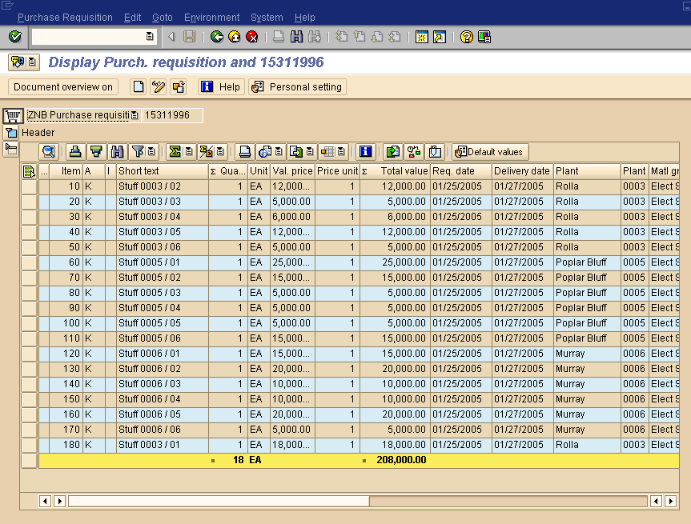
Figure 1 PR 15311996 in QA3 01/26/2005

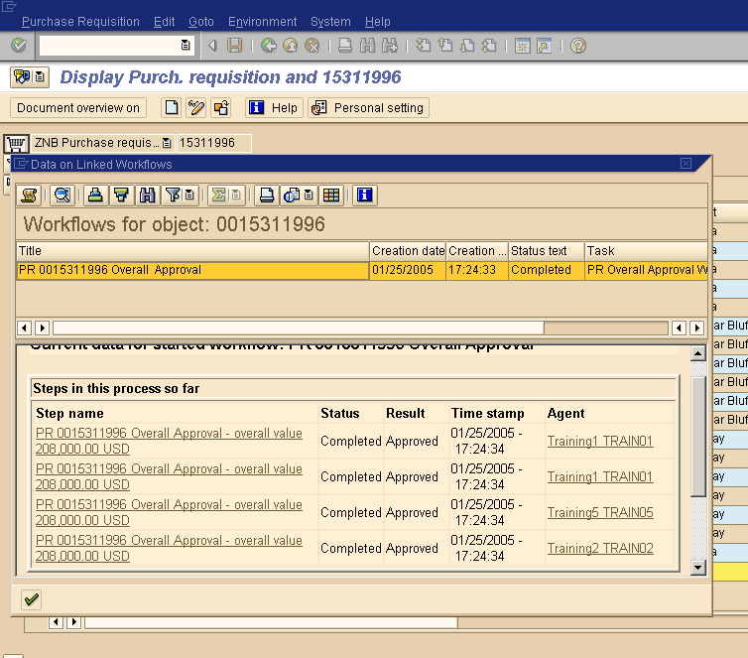
Figure 2 PR 15311996 Overall Approval Status

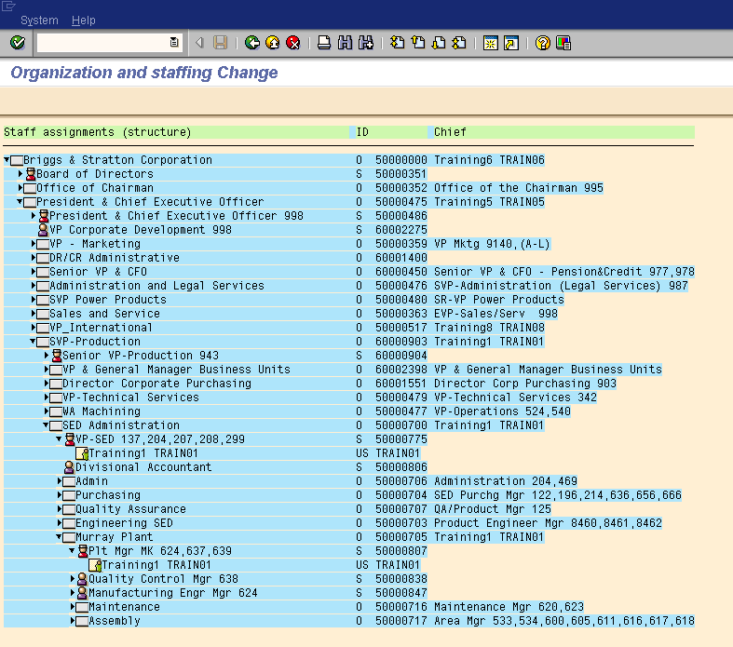
Figure 3 QA3 SAP Org_Structure for SED (Rolla, Poplar Bluff, and Murray Page 1)

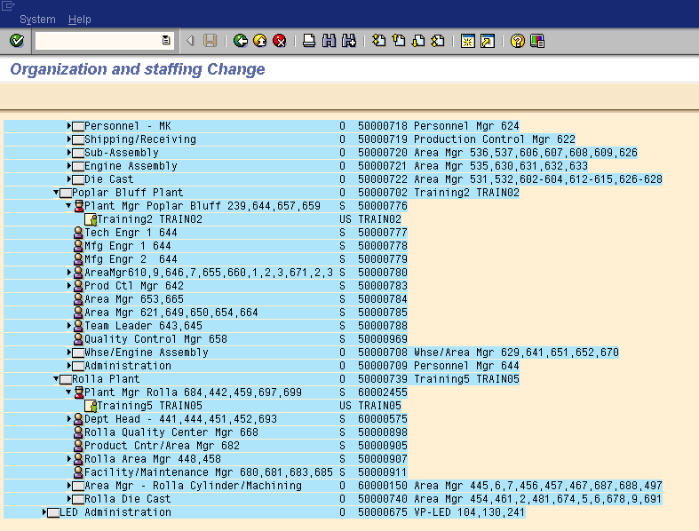
Figure 4 QA3 SAP Org_Structure for SED (Rolla, Poplar Bluff, and Murray Page 2)

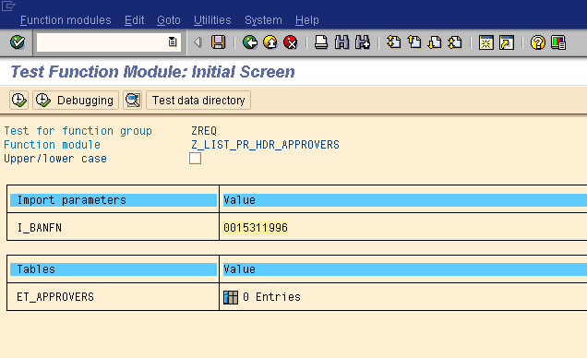
Figure 5 Input into Function Module Z_LIST_PR_HDR_APPROVERS

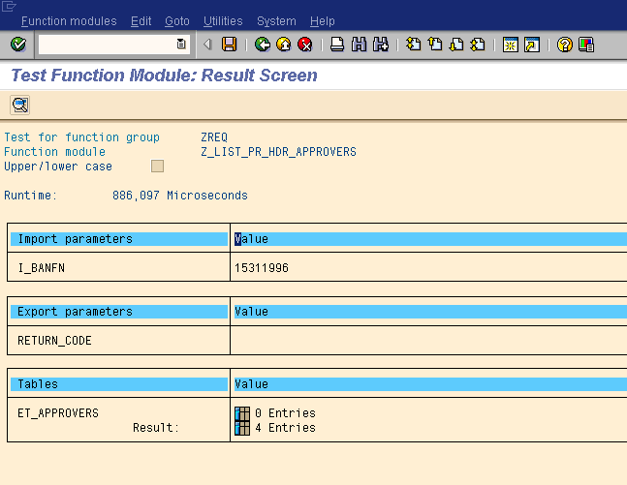
Figure 6 Output (Page 1) from Function Module Z_LIST_PR_HDR_APPROVERS

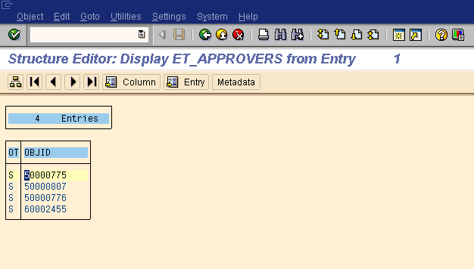
Figure 7 Overall Dollar Approval Positions selected for PR 15311996

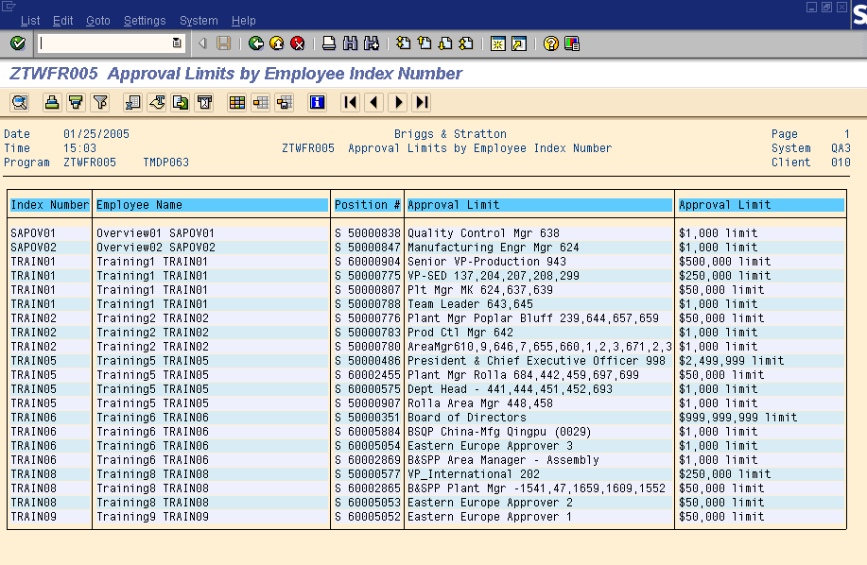
Figure 8 Approval Limits for the Overall Approval Positions selected for PR 15311996

