Scopus Cited-By- Counts: integration on your Full Text platform.

You can now include Cited By counts for the journal articles on your Full Text platform. This will immediately improve your site’s user experience, by providing useful information on your articles to your subscribers, highlighting the scientific value of your articles. The source of these Cited By counts is Scopus, a database of high-quality, peer-reviewed material covering more than 15.000 journals, including over 265 million references (going back to 1996). These references are linked back to your articles with 99.2% precision and 97.8% recall, giving the most comprehensive and accurate Cited By counts in the industry, PLUS the link back to the citing articles bibliographic information in Scopus.

How would it look?
On the article summary page the user would see a Cited By count – in the example below as a hyperlink on the right hand side of the page. However, you can customize this to fit seamlessly in the layout of your Full Text platform. Other possibilities are to include it on the issue or volume Table of Contents or as part of search results. The count is provided in real time and is re-calculated each time a user returns to your site or runs a new search – giving the most up to date Cited By counts at any time, as the Scopus database is updated daily.

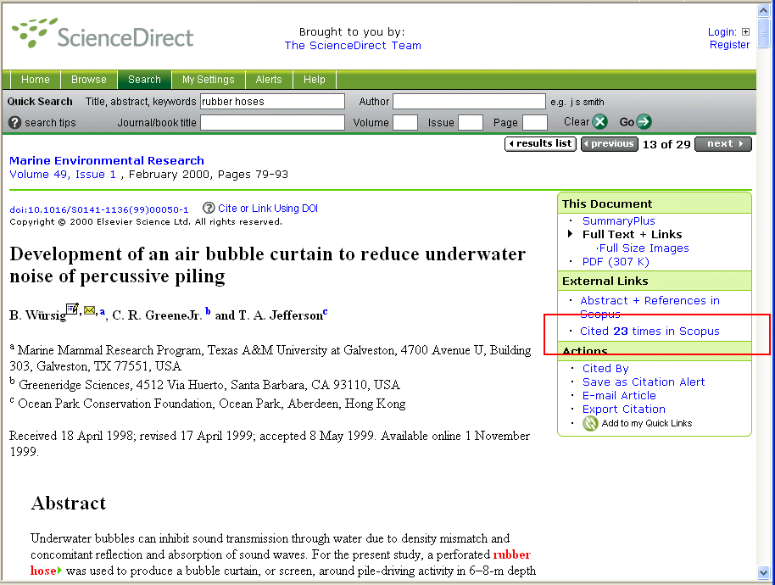

What happens next?
Our user testing showed that knowing how often an article has been cited already provides tremendous value to the readers of an article. An additional benefit the Cited By counts from Scopus provide is direct access – by clicking on the ‘Cited x times’ link - to the bibliographic information of the articles citing your publications.

Any user of your Full Text platform can click on the ‘Cited x times’ link, and view the bibliographic details on scopus.com. Scopus customers will obviously have full navigation capabilities after clicking on the link. However, Scopus is also providing all the relevant information about the citing articles for those of your patrons who do not have a subscription to Scopus, with limited access to the other functionality within Scopus. For an example of the bibliographic details please see below.

