
iCampus Spring Review

prepared by:
OpenWetWare Steering Committee
http://openwetware.org/wiki/Steering_Committee

iCampus PI: Jason Kelly
iCampus Advisors: Drew Endy, Natalie Kuldell

Table of Contents

Table of Contents 1

Introduction 2

Status of Spring Milestones 3

Additional Accomplishments 6

Publications 7

Posters and Presentations 8

News Articles 9

Introduction
We are requesting further funding through iCampus in order to continue pursuit of the goals outlined in our iCampus proposal:
“We propose to expand the OpenWetWare user community, develop tools to encourage contribution, and integrate content development with educational programs in the hope of creating a critical mass of users that will lead to a self-sustaining resource for the biological community.”
We have already made significant progress towards these goals in the five months since receiving our iCampus grant, and additional funding would enable us to keep up our current rate of community growth – approximately tripling in size since January.

Status of Spring Milestones
We have largely met all of our Spring milestones, as well as some of our one-year milestones. We set Spring goals of tripling our community size and site traffic to 30 academic labs, 750 users, and 3000 unique visits/day. We currently have 47 academic labs, 736 registered users, and 2400 unique visits/day. Additionally, we pledged to send representatives to 2 conferences to promote OWW. We had representatives at International Conference on Systems Biology, MIT Biological Engineering department retreat, international Genetically Engineered Machines Competition instructor’s workshop, and Synthetic Biology 2.0.
We also set spring goals to improve the content on OpenWetWare, including developing:
- An automatic method to convert wiki->static webpage directly hosted on openwetware
  - Status: Completed. The method to "de-wikify" pages was developed successfully and is used by many labs on their homepages (see Figure 1)
- Templates for protocols, equipment, materials, biologicals; Also, better organization scheme to encourage use and standardization of the shared information.
  - Status: In progress. Templates are still being developed, but significant work has gone into better organization of site discussions via development of a Community Portal to better coordinate activities among the more active OWW members. (see Figure 2) The bulk of the community portal design was done by a UROP student hired with funds from iCampus.
- Integration of BE.109 (Laboratory Fundamentals of Biological Engineering) curriculum with OpenWetWare.
  - Status: Completed. BE.109 was hosted on OWW during Spring 2006. All students posted content regarding experimental results on OWW. Many students also contributed directly to improving the class content (such as fixing errors in experimental protocols and posting troubleshooting tips). This sort of active student participation in improving the course content is what we hoped OWW would provide BE.109. Additionally, plans are underway to archive content from BE.109 Spring 2006 on MIT's OpenCourseWare. (see Figure 3) Another course, BE.180 (Biological Engineering Programming) also hosted its course page on OWW.
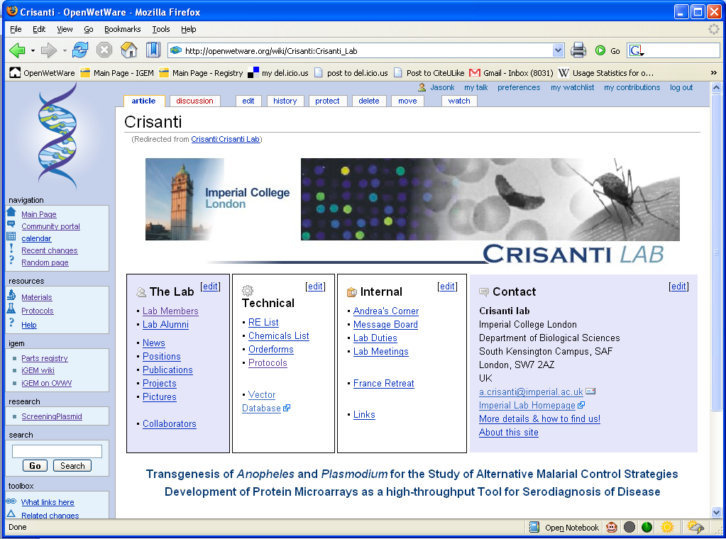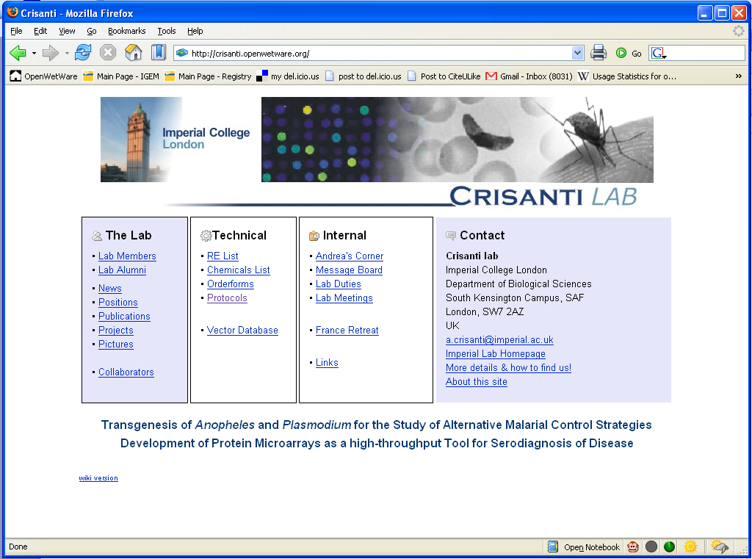
Figure 1: The webpage on the left is the OpenWetWare wiki page for the Crisanti lab at Imperial College London (http://openwetware.org/wiki/crisanti). The page on the right is the “de-wikified” version found at http://crisanti.openwetware.org/. This feature is used by nearly every lab on OWW.
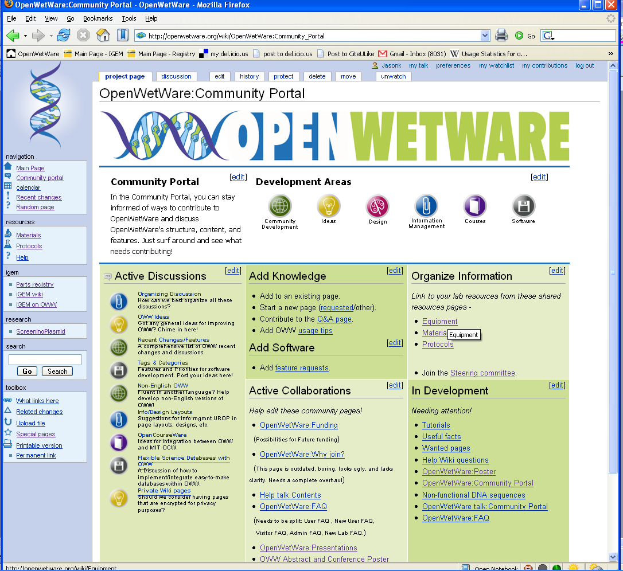
Figure 2: The community portal includes sub-areas: Community Development, Ideas, Design, Information Management, Courses, and Software. Active discussions and collaborations are highlighted here to encourage contribution.
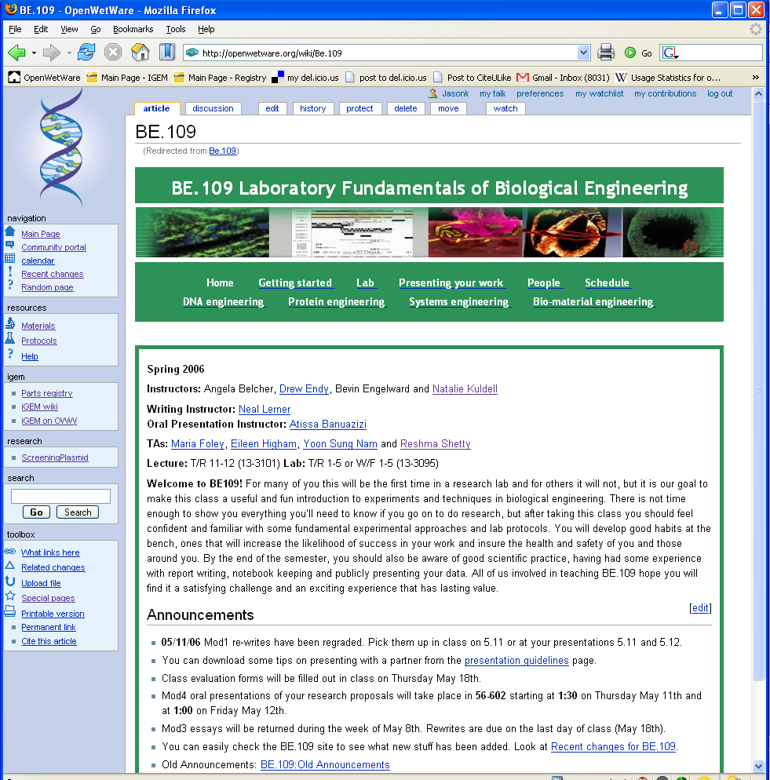
Figure 3: The wiki for the Spring 2006 BE.109 course at MIT. All the students had accounts on OpenWetWare and could contribute to course materials.

Additional Accomplishments
We undertook a number of other projects that were not officially stated in the milestones, but still contributed dramatically to the growth of OpenWetWare:
- We commissioned a professional artist to create a logo, site design, and advertising materials for OWW. We expect the professional site design and advertising materials will help new users navigate the site, and more easily find community areas where they can contribute.
- One of the iCampus-supported UROP students developed a custom user management system to streamline the process of adding new members to the site. This system has dramatically increased our turn around time in responding to new user requests.
- The first OWW Open Science Seminar at MIT was given by John Wilbanks of the Science Commons. The lecture was videotaped and is available on OWW. The seminar series serves to increase the visibility of OWW in the scientific community, as well as bring up issues related to the mission of OpenWetWare. The next lecture will be given by Michael Eisen, co-founder of PLoS.
- We have organized the OpenWetWare steering committee and hold monthly meetings (via teleconference) to help ensure community leadership continues after the iCampus grant expires.
- The committee commissioned regular “OpenWetWare Highlights” to celebrate and encourage quality contributions by showcasing them on the main page.
- We have developed a number of custom software extensions to the MediaWiki software specifically geared towards OWW users. These include extensions that:
  - Allows users to customize their recent changes to make it easier to track changes of a particular set of pages. For instance, changes on their lab webpages.
  - Modify the ShowHide extension allowing showing/hiding all, enabling easier navigation of the site.
  - Allow users to change their personal default page to a page other than the general OWW Main Page, so they could enter OWW on their lab page, for instance.
  - Allow users to personalize their sidebar links enabling easier navigation of the site.
  - Make it easy to extract a portion of one wiki, rewriting all page titles and links, and import it into another wiki. This is useful for merging an external wiki with OWW.

Publications

OpenWetWare currently consists of ~7000 total pages, more than 150 protocols, 75 materials pages, and 50 equipment pages. (Figure 4) Not to mention the large number of research pages posted by the 47 labs on OpenWetWare. The site itself is a dynamic, growing publication.

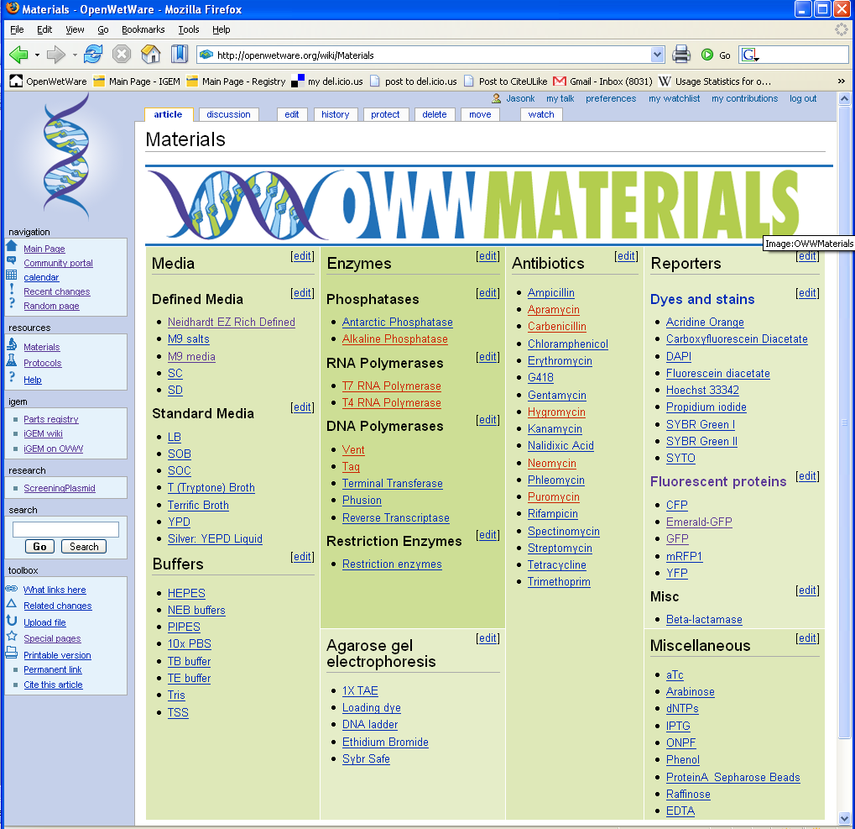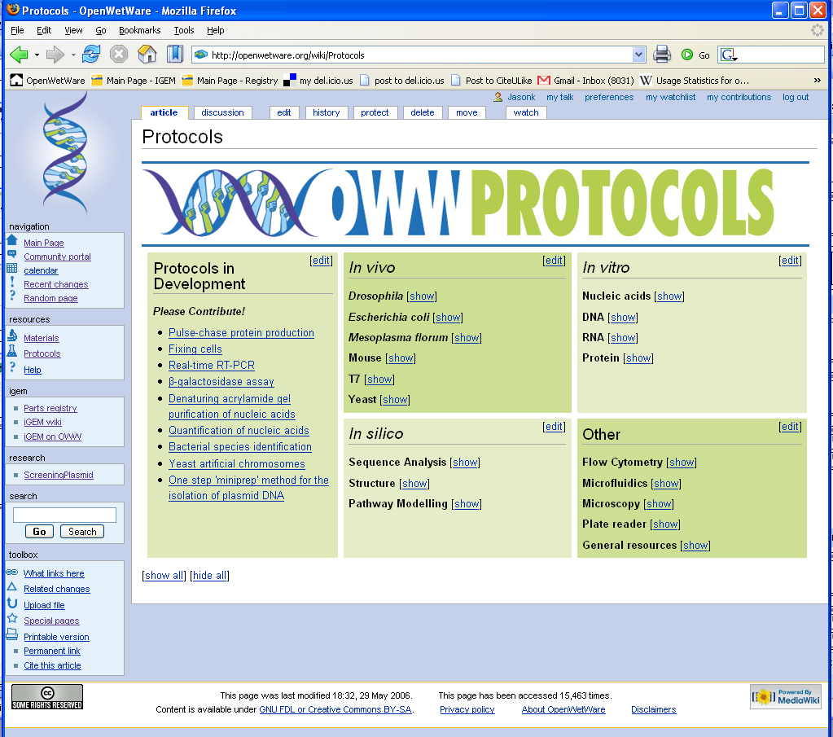

Figure 4: Materials and protocols pages on OpenWetWare. All information contained here is generated by the community and is available freely.

Posters and Presentations

We have presented a poster (Figure 5) at several academic conferences in order to recruit new users. We have given a number of presentations, typically to labs in the Boston area requesting a tutorial of the site. These presentations are given as a tour of the site rather than as a Powerpoint, however you can find the walkthroughs here: http://openwetware.org/wiki/OpenWetWare:Presentations

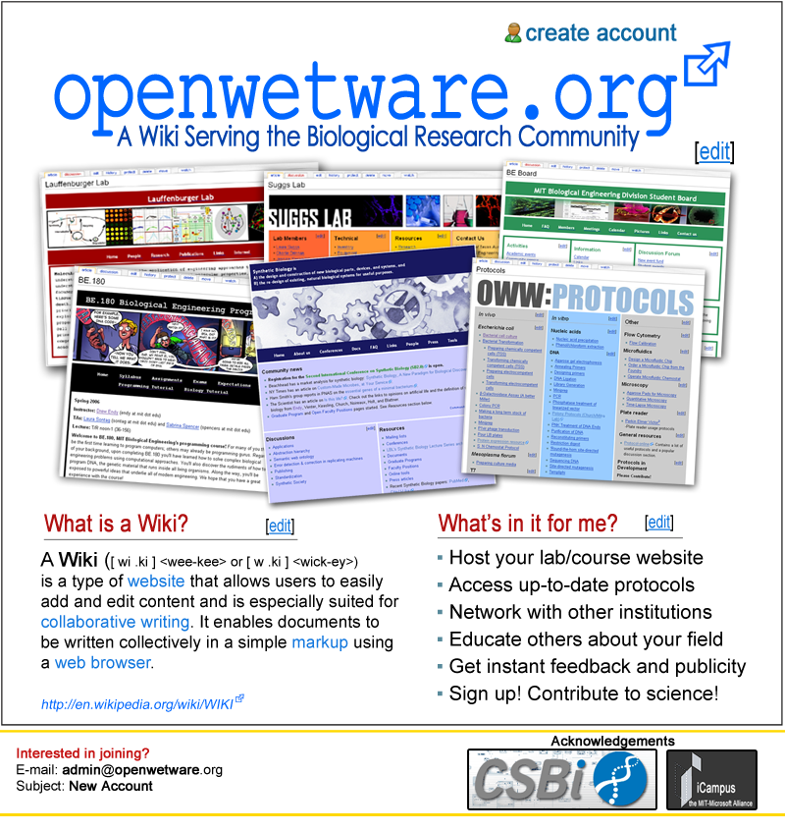
Figure 4: OpenWetWare poster for recruiting new labs.

News Articles

OpenWetWare has been featured in the following news articles. We have attached copies of each article at the end of this document.

Wikis: Lab Partnering Science, January 6, 2006.
BLOG and WIKI your science Biotechnology Journal, December 27, 2005
Science in the web age: Joint efforts Nature, December 1, 2005.

Budget Review
- Materials & Services - $1315.11 (total)
  - Artist for site design, logo, poster - $1200
  - Printing posters, business cards - $115.11
- 2 UROP students working part-time in the spring - $2750.85
- Meetings (food,beverage,voice conference device) - $306.82
- OWW seminar series (A/V, speaker lunch) - $700
- Overhead - $3145.06
- Total: $8217.73
While we still have some of our current funding remaining, there are a number of projects that would be enabled by receiving further funding from iCampus.

1. OpenWetWare Mediawiki distribution
We have had requests from several labs that would like to run their own wiki, but want to have easy installation of the custom extensions for Mediawiki that we have developed for OpenWetWare. To solve this problem we would like to develop an OpenWetWare-branded distribution of Mediawiki for scientists. We also expect that the distribution could serve as a mechanism for driving more users to OpenWetWare, particularly those who may at first be hesitant due to the public nature of the site. We will include mechanisms such as a “publish to OWW”-button that would enable simple uploading of private wiki content to the public OpenWetWare site. Additionally, sharing a common Mediawiki distribution in the biological sciences would enable tools developed by various groups to be more rapidly distributed to the broader community.

2. Apply for 501(c)3 status
501(c)3 non-profit status will enable OpenWetWare to apply for further funding after the iCampus grant terminates.

3. Greater online advertising effort
The site has been growing “organically” for the first year of its existence, with little in the way of advertising beyond word-of-mouth and posters at a few conferences. This approach enabled us to grow at a speed which was manageable, while at the same time fostering a core group of users dedicated to maintaining and supporting OpenWetWare. However, with the automated new user management system, as well as infrastructure developed on the wiki (in particular the community portal), we are now in a better position to increase our recruiting efforts. Targeted advertising via Google Adwords, as well as advertising on popular biology websites/magazines will likely lead to a dramatic increase in new membership on the site.

We have undergone tremendous growth in both user base and infrastructure over the past 5 months, while judiciously managing the resources we have received from iCampus. We expect that further funding in support of the goals highlighted above will allow similar rapid growth over the reaminder of the year.

