Label-free multimodal intravascular imaging

Hongki Yoo, Ph.D.
Associate Professor, Department of Mechanical Engineering,
Korea Advanced Institute of Science and Technology

Time: Friday September 23 12:00-1:00 pm
Location: 4-370

Abstract: Recent advancements in optical fibers, lasers, and optical imaging techniques have introduced miniaturized fiber-based micro-endoscopy technology for use in a variety of biomedical applications. Especially, miniaturized fiber-based endoscopic imaging probes for optical coherence tomography (OCT) have been successfully translated into clinical diagnostics. While gray-scale OCT provides only the microstructural information of biological samples, multimodal endoscopic imaging techniques using double-clad fiber can provide comprehensive information, such as inflammatory activity, molecular information, and biochemical composition, on top of the microstructure. In this talk, we will discuss the technical advances of various fiber-based micro-endoscopy technologies and its biomedical applications. In particular, we will present label-free multimodal intravascular imaging that combines OCT and fluorescence lifetime imaging for diagnosing cardiovascular disease. These newly developed endoscopic imaging technologies can provide an opportunity to investigate a variety of diseases, including cardiovascular and gastrointestinal diseases.

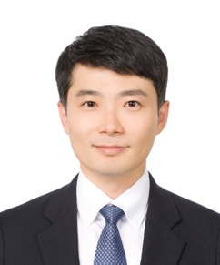
Biography: Dr. Hongki Yoo is an associate professor in the Department of Mechanical Engineering, KAIST, Korea. Professor Yoo received his B.S., M.S., and Ph.D. in Mechanical Engineering from KAIST. He has worked as a postdoctoral research fellow and an instructor in Wellman Center for Photomedicine at Harvard Medical School and Massachusetts General Hospital. He led Biomedical Optics and Photomedicine Lab in the Department of Biomedical Engineering, Hanyang University, 2021-2019. After that, he joined KAIST in 2019 to lead Biomedical Optics and Optical Metrology (BOOM) Lab. His research topics include multimodal optical imaging, endoscopic imaging, optical coherence tomography, diagnostics and therapeutics of cardiovascular disease, 3D metrology, and machine learning in optical imaging. For more information on Professor Yoo’s research topics, please visit his website at https://boom.kaist.ac.kr

