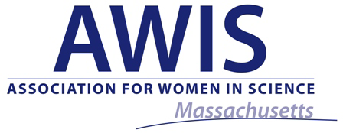


Writing in Science - Career Panel
© Py2000 | Dreamstime.com - Pen Notebook Computer Photo

Interested in a career in science writing? Having trouble finishing up that final paper? These panelists have seen and heard it all! Come join us for an intimate panel discussion with some of the industry’s top science writers.

Panelists:
- Dr. Susan Wu (Vertex Pharmaceuticals)
- Alice Lim (Custom Learning Designs)
- Dr. Chandreyee Das (EMD Millipore)
- Dr. Alison Mungenast (The Picower Institute - MIT)
- Dr. Maria Naylor (Biogen Idec)

Discussion moderated by Dr. Janice Kranz

Tuesday, October 20th, 2015 • 6:00 – 8:30 pm
Location: The Broad Institute, Monadnock Room
(415 Main St. Cambridge 02142)

6:00-6:30 pm: Light refreshments and networking
6:30-8:00 pm: Panel Discussion
8:00-8:30 pm: Networking

To Register, Visit: www.massawis.org/WritingCareersinSci2015
MASS AWIS & Broad members $5 · Non-members $12

Register before Oct. 13th for a chance to win a Starbucks gift card!
To learn more about MASS AWIS and other upcoming AWIS events, please visit www.massawis.org
Join AWIS to save money on events and to support our work!

