How to Feel As Bright and Capable
As They “Think” You Are
Why Smart People Suffer from the Impostor Syndrome
and How You Can Thrive In Spite of It

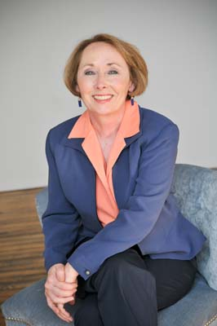
Do you secretly worry that others will find out you’re not as intelligent and competent as they seem to think you are?

Do you often dismiss your accomplishments as a “fluke” or “no big deal?”

Do you think, “If I can do it, anyone can”?

Do you sometimes shy away from taking on even greater challenges because of nagging self-doubt?

Are you crushed by even constructive criticism, taking it as evidence of your ineptness? If so, join the club!
Key Take Aways
- Why the impostor syndrome is not “just low self-esteem”
- Creative ways “impostors” discount or minimize their success
- Perfectly good reasons why smart people feel like frauds
- How your personal Competence Type may be setting you (or your employees) up to fall short
- Procrastination, holding back and other unconscious coping strategies “impostors” use to avoid being found out
- The cost of the impostor syndrome on organizations
- Why women are both more susceptible to and held back by impostor feelings
- Practical steps to help yourself, your employees, or high achieving children to interrupt the impostor syndrome and end needless self-doubt
You’ll walk away with practical strategies for interrupting the Impostor Syndrome that you can start using immediately. By applying these simple but powerful techniques you'll finally be able to begin to see yourself as the bright, competent person you really are!

Dr. Valerie Young is an internationally known speaker and the author of the award-winning book The Secret Thoughts of Successful Women: Why Capable People Suffer from the Impostor Syndrome and How to Thrive in Spite of It (Crown/Random House) now available in five languages including Russian. Valerie has addressed such diverse audiences as Chrysler, Intel, IBM, P&G, Boeing, Merck, McDonalds (Europe), Society of Women Engineers, American Women in Radio and Television, and faculty and students at over 60 other colleges and universities including Harvard, Stanford, and Princeton. Her work has been cited in such publications as The Wall Street Journal, USA Today Weekend, Entrepreneur, Kiplinger’s, Inc., The Chicago Tribune, Sydney Morning Herald, More, The Globe & Mail, Woman’s Day, Redbook, and the Irish Independent.

