POSTDOCS!
Celebrate 19th de Junio!
FOR FREE!
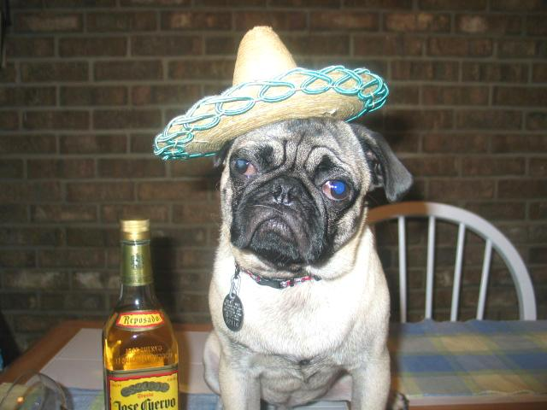
Postdoc Pub Night
@ Muddy Charles Pub
Tuesday June 19th
7PM - ??

