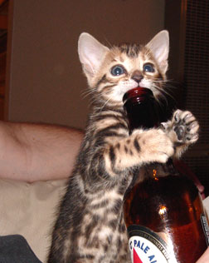

Hey, Dr.!
Eat . . . for free!
Drink . . . for free!
Be Merry. . . for free!
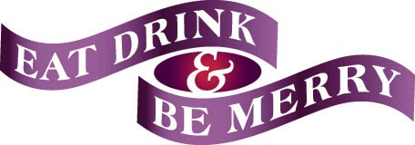
Post-Doc Pub Night
Muddy Charles
May 22nd, 7PM-??

