Got your PhD?
Get FREE FOOD!

Postdoc Pub Night
@ Muddy Charles Pub
Tuesday April 17th
7PM - ??

Eat samosas, root for the sox!
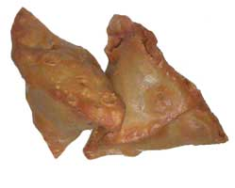 | + | 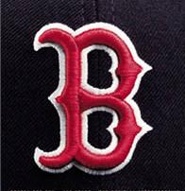 | eer=fun!

