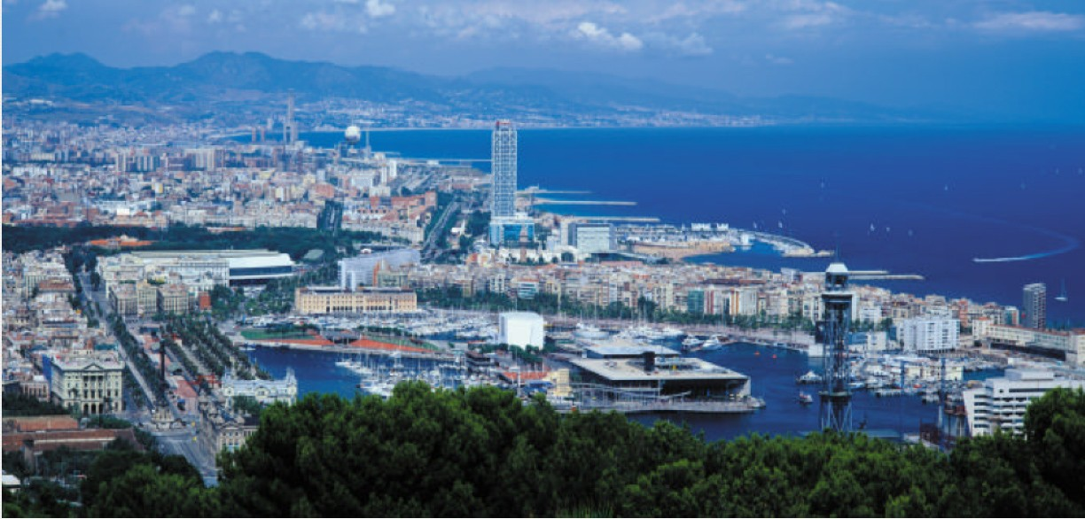

Cocktail Networking
Barcelona comes to Boston

The Barcelona Chamber of Commerce and Barcelona Activa together with a delegation of some 20 IT and Biotech companies from Barcelona, cordially invite you a reception and networking session that will take place at
MIT – Faculty Club
50 Memorial Drive, 6th Floor, Cambridge, MA 02139

on July 25th , from 7 to 9 pm

Please confirm your attendance at the following email addresses:
carme.cunyat@barcelonactiva.es and eperea@mail.cambrabcn.es

