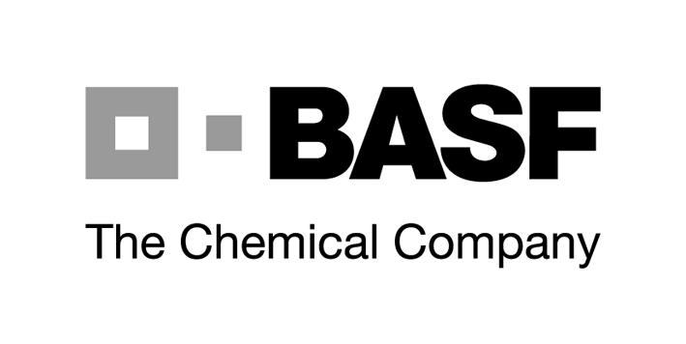
BASF Postdoc Forum

August 17-19, 2006

at the North Carolina Agricultural Research Center

of BASF Corporation

Raleigh, North Carolina

Participants: European Postdocs working at a University in the US

BASF Aktiengesellschaft in Ludwigshafen, Germany, and BASF Corporation, USA will be holding a two-day forum together with 40 chemists who are completing their postdoctoral studies in the US. The forum is scheduled for August 17 - 19, at the North Carolina Agricultural Research Center in Raleigh.

The forum will offer young European scientists from different working groups the opportunity to find out more about BASF's research activities. Participants will not only have the opportunity to talk to young chemists from our central research facilities but also to meet representatives of the management. We would also like to present and discuss with participants the diverse employment and career opportunities for chemists within the BASF Group.

Our Agricultural Center is located in one of the largest research parks in the world in proximity to and close affiliation with the three illustrious universities that form the points of a triangle around it: Duke University in Durham, the University of North Carolina in Chapel Hill and North Carolina State University in Raleigh.

The participants are guests of BASF during the course. BASF will cover the travel expenses and care for board and lodgings.

We look forward very much to receiving applications from postdocs with an excellent background in preparative organic or inorganic chemistry, polymer chemistry or technical chemistry!

How to apply: Please send your application documents (application form, letter of
motivation, resume (CV)) to kathrin.becker@basf.com
not later than July 15, 2006

