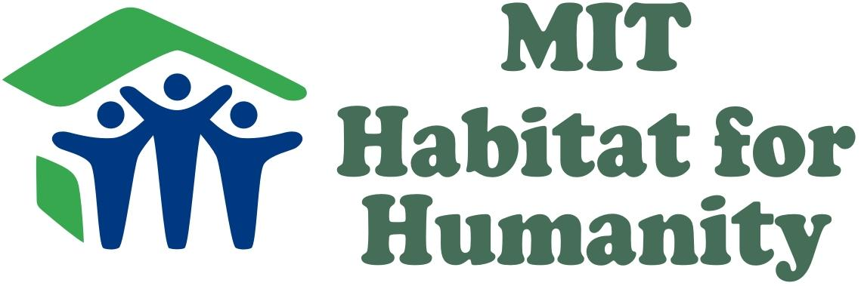
MIT Habitat for Humanity is dedicated to encouraging MIT undergraduate and graduate students to volunteer with Habitat, and to increasing awareness of the global housing crisis.

Volunteer Opportunities


- Local build days:
2-3 Saturdays each month, 10-20 MIT students go to local Habitat construction sites and spend the day working on a Habitat home. No experience is required! Students usually meet and work alongside the families that will be receiving Habitat homes.
- Spring break trip:
Each year, approximately 14 MIT students travel to a Habitat affiliate in a needy part of the country during spring break. They spend the week working on Habitat homes, and explore the area in their free time.

On-Campus Events

- The Beaver Dash:
An annual on-campus 5K race, fundraising to sponsor MIT Habitat homes. Raised enough money to sponsor a home in Kenya during its inaugural year (Oct 2009)!

- Campus Build:
Teams compete in a cardboard-house-building competition each April on Kresge Oval, right outside of the student center. Students also build tables and other items for local Habitat affiliates right on campus.

- Habitat Benefit Concert:
Each February, student performance groups come together to put on a show in order to raise funds and awareness about Habitat.

