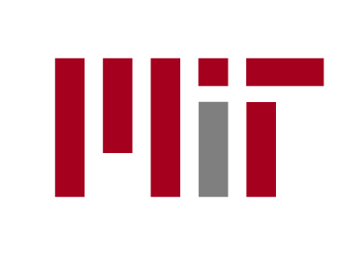
CAMPAIGN FOR STUDENTS

Campaign for Students Launch
Blurb for IDF students

The Campaign for Students aims to increase funding levels for financial aid and student life initiatives to enhance both the educational and living environments for MIT students.

On October 3, 2008 the launch of the Campaign will be publicly announced. Approximately 300 alumni and friends will be on campus for a day which includes an academic deans panel, the International Development Fair, a luncheon focused on UROP’s, afternoon breakout sessions and concludes with an evening gala.

The International Development Fair has been incorporated into the launch day programming to allow for alumni to interact with students and learn about some of the international work here at MIT. Between the hours of 11:30 am to 1:00 pm, our guests will be encouraged to tour all that IDF has to offer. We hope that you will take this opportunity to engage in conversations with the alumni and friends and share your personal stories about the amazing and interesting international development activities and projects that you have been involved with.

If you have any questions, please do not hesitate to contact Laura Adler at 617-253-7966 or by email at ladler@mit.edu.

Regards,

The Office of the Campaign for Students

