Myths Uncovered

- Habitat gives houses away to poor people
Habitat offers homeownership to families unable to obtain conventional house financing; families make a $500 down payment and contribute 500 hours of “sweat equity” on the construction of their home
- Habitat houses reduce surrounding property values
Affordable housing has no adverse effect on other neighborhood property values; habitat homes have actually increased property values
- Only African Americans receive Habitat homes
Habitat builds houses in partnership with those in need—regardless of race, religion, or any other difference—who meet 3 criteria: ability to repay the no-interest, no-profit mortgage; willingness to partner with Habitat; and need.
- You have to be Christian
Habitat is a Christian organization but homeowners are chosen without regard to religion; Habitat welcomes volunteers from all faiths who actively embrace Habitat’s goals
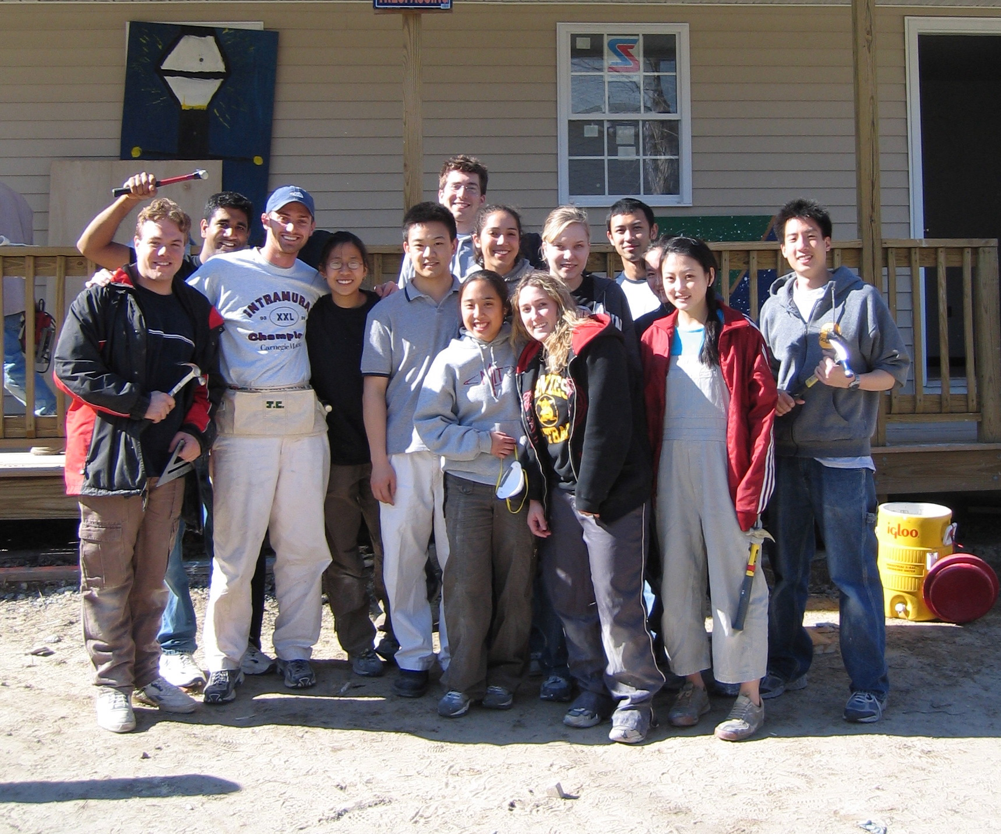

The MIT Chapter

- We are a small organization with 10 members on an exec board and a volunteer base of 400
- Members include undergraduate and graduate students, alumnae, and MIT community members
- Our local affiliate is Merrimack Valley Habitat in Lawrence, MA
- Hold workdays once a month
- Have raised from $2000 at our annual fundraiser
- Provide opportunities on-campus with our annual “Campus Build” where we have built 40 window frames at MIT and then transported them to a Habitat storage facility
- Are looking to raise more awareness about Habitat’s goals by holding a “Helping Hands for Humanity” in the fall to reach out to the Boston community

For more information, contact:

- Our Chapter:
MIT Habitat for Humanity
mit-habitat@mit.edu

Lindsey Pete
52 Massachusetts Avenue
Cambridge, MA 02139
lpete321@mit.edu
Co-President

Elyse Pieper
480 Commonwealth Ave
Boston, MA 02215
epieper@mit.edu
Co-President

- Our Affiliate:
Merrimack Valley Habitat
60 Island Street
Lawrence, MA 01840
(978) 681-8858
www.merrimackvalleyhabitat.org

- The Organization:
Habitat for Humanity International
121 Habitat Street
Americus, GA 31709
(229) 924-6935
publicinfo@habitat.org

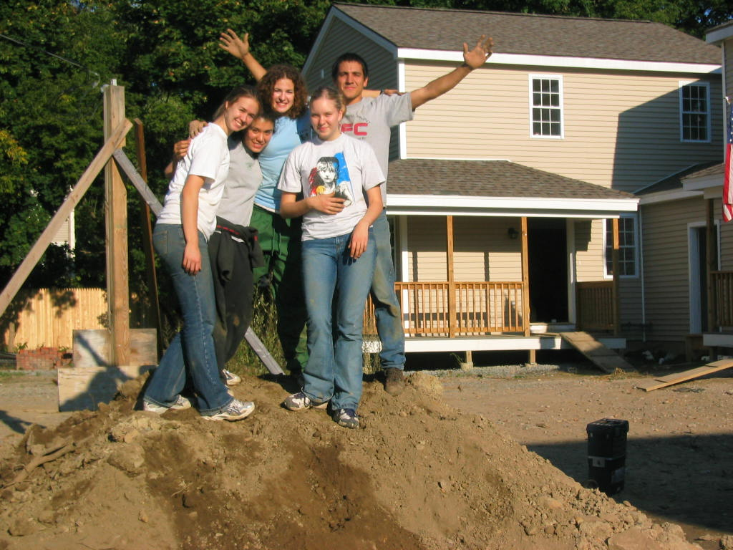

About…

- Habitat is a nonprofit, Christian housing ministry seeking to eliminate poverty housing and homelessness
- Habitat has built more than 200,000 houses around the world
- Habitat builds houses through volunteer labor and donations of money and materials
- Habitat homes are financed with affordable, no-interest loans
- Monthly mortgage payments are used to build more homes
- Donations to Habitat are used as designated by the donor
- Habitat does not accept government funds but does consider government agencies partners in its mission
- Each affiliate has a family selection committee choosing homeowners based on need
- Habitat’s work is accomplished at a community level by affiliates—independent, locally run, non-profit organizations
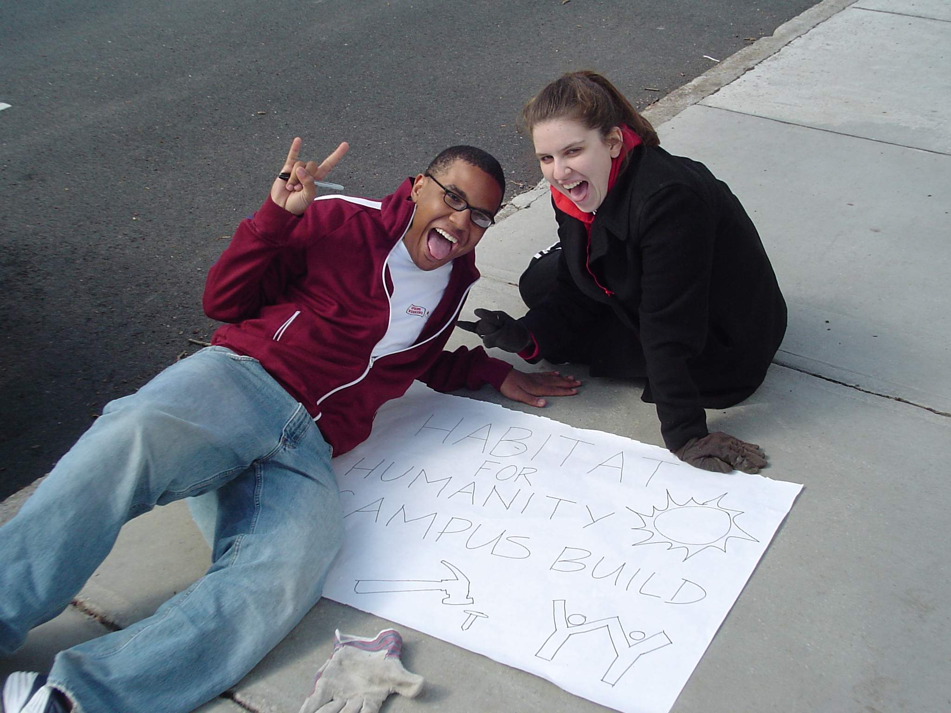

Upcoming Events

- Workday
Saturday, April 15
Worksite in Lawrence, MA
8:00 am – 5:00 pm
Helping to build a home

- Eat Your Heart Out
Friday, April 28
Lobby 10 of MIT
9:00 am – 5:00 pm
Breakfast Fundraiser

- Campus Build
Saturday, April 29
Kresge Oval of MIT
8:00 am – 3:00 pm
Building wall frames

- Helping Hands for Humanity
Saturday, September 23
Boston Commons
9:00 am – 6:00 pm
Awareness celebration

