A Musical Benefit Celebration

for
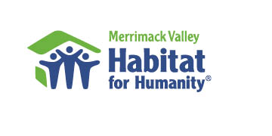
Sunday, September 25

4:00 – 5:30 p.m.

at
South Congregational Church

198 South Broadway, Lawrence

“Building Hope
in Lawrence”

*DISPLAYS AND INFORMATION ON THE WORK OF HABITAT *

AN OFFERING WILL BE TAKEN TO SUPPORT THE WORK
OF GREATER LAWRENCE HABITAT FOR HUMANITY

For More Information: 978-683-2193

Featured Performers
- James R. Stewart, Jr., organist, South Congregational Church
- James Connor (recorder), Kristin Turner (flute), Sylvia Chang (violin)
- The SunRise Singers (Andover Senior Center)
- Eliseo Ortiz, soloist, New Life Hispanic UMC, Chelsea
- The Gentleman Songsters

