
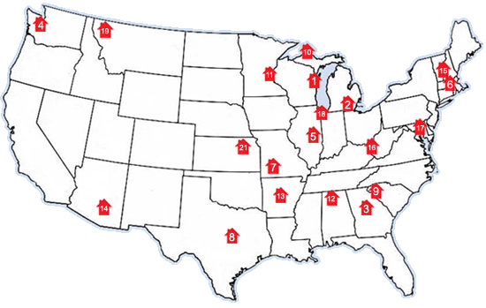
Pedaling to End Poverty Housing

Bike & Build Grants

About the Grants Program

What is the Bike & Build Grants System?

This summer, Bike & Build will disburse approximately $100,000 in grants to affordable housing organizations throughout the country. These funds have been raised by the participants on our-cross country bicycle trips, who will also be building houses and generating publicity throughout their trips.

What projects are eligible for funding?

Our program aims to mobilize young adults, ages 18-25 to impact the affordable housing cause. The funds are reserved for housing projects which involve students and young adults. Typical recipients in the past have included campus chapters of Habitat for Humanity, and other affordable housing groups with projects that work with young adults.

If I know of an eligible project, what can I do?

Encourage them to apply! We enjoy receiving applications from towns along our routes. There is an application form and comprehensive information about our grants program available on the ‘Grants’ section of our website, www.bikeandbuild.org.

How large are the grants?

Bike & Build grants will range from $500 – $10,000

When are applications due?

Applications are due by May 1st, 2005.

2004 Grant Recipients
In 2004, Bike & Build awarded $73,025 in grants to 21 projects across the country. Details are available at www.bikeandbuild.org

About Bike & Build

Bike & Build is an independent nonprofit organization, and an integrated, strategic part of providing affordable housing in the communities where we operate. Through our events, Bike & Build directs funds, volunteers, and community and media attention to affordable housing efforts. Our programs act as catalysts to build homes, foster the spirit of service, and empower young adults.

More information about Bike & Build – including our business plan, complete trip itineraries, and photos and journal entries – is available on our web site www.bikeandbuild.org

