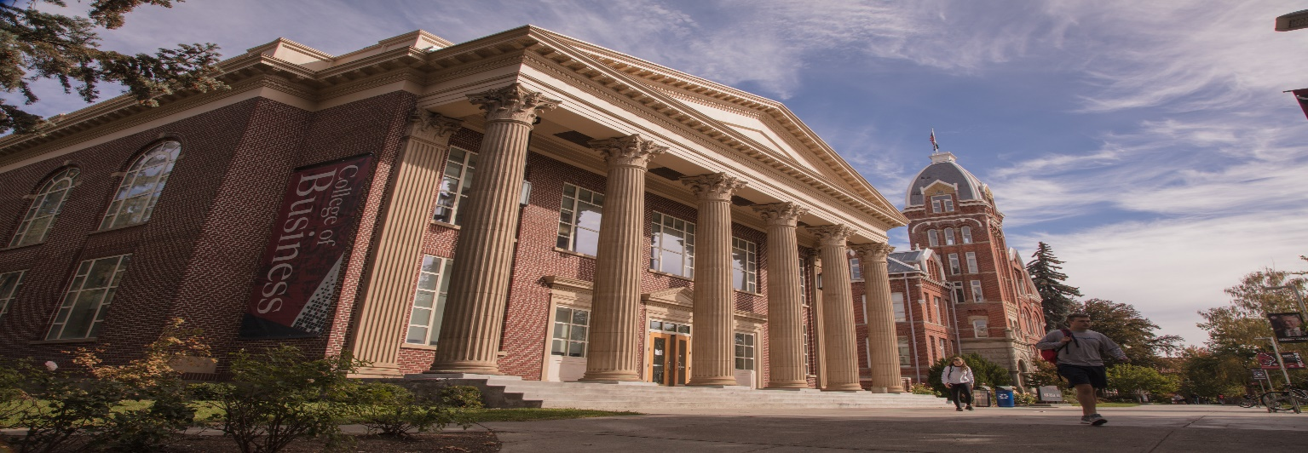

**Dean of the College of Business**

**Central Washington University**

Central Washington University (CWU) invites nominations and applications for the position of Dean in the College of Business. CWU seeks a collaborative, strategic, and visionary leader. The dean will have the opportunity to lead and build upon the college’s successes while supporting and creating areas of growth. The next dean will be a forward-thinking visionary, leading the College of Business by engaging and supporting students, faculty and staff. The College of Business will thrive with a dean who is committed to excellence in business education, diversity and inclusivity, enhancing its reputation in the local and business communities, and fundraising.

CWU is located in Ellensburg on the sunny side of the Cascade Mountains in Washington State. Ellensburg is surrounded by snow-capped mountains, canyons, waterfalls, rivers, hundreds of miles of hiking trails and bike paths, community forests and vineyards. The historic downtown includes multiple galleries, local craft brewery taprooms, local wine cellars and restaurants. The town of 21,000 (including students) has programming throughout the year including Ellensburg Music Fest, Brewfest, monthly art walks, a vibrant summer farmers market, Dachshunds on Parade, the County Fair, and the largest rodeo in the state. (To learn more about Ellensburg, click here: <https://www.cwu.edu/hr/life-ellensburg>). The cosmopolitan city of Seattle – home to 11 Fortune 500 company headquarters --and the beautiful Puget Sound are only 2 hours away.

CWU is a comprehensive, regional university of approximately 9400 students focusing primarily on undergraduates, is led by an inspiring new president, Jim Wohlpart. CWU prides itself on being a model learning organization of equity and belonging. We have been named a Fulbright U.S. Scholar Program Top Producing Institution for the 2022-2023 academic year. In addition, for the seventh time in eight years, CWU is a recipient of the prestigious Higher Education Excellence in Diversity (HEED) Award from INSIGHT Into Diversity magazine. We deliver educational and social activities on our residential campus in Ellensburg, Washington and at our 8 off-site locations throughout Washington, including 5 in the Seattle area. Tour our campus in Ellensburg here. [www.youtube.com/watch?v=HjdhOegDa9A](http://www.youtube.com/watch?v=HjdhOegDa9A).

The College of Business is proud of its diversity in the faculty and student body. There are approximately 1350 students (many of them first generation) in the College, 45 Full-Time faculty (37 T/TT) and 21 quarterly instructors. The College offers diverse undergraduate programs: the BSBA (7 specializations), BS degrees (Accounting, Economics, Entrepreneurship, Personal Financial Planning), a BAS (supply chain) and a graduate program in Accounting (MPA). It is a collegial environment where faculty are dedicated to student learning while pursuing scholarship. Faculty and staff are innovative with curriculum planning and student engagement. The College is in good standing with the AACSB, and has begun work on its next review (in AY 2025-6) with creating new Mission and strategic plan. There is excellent potential for deepening the College’s ties with the local community and enhancing our societal impact. For more information about the College of Business, please visit our website: [www.cwu.edu/business/](http://www.cwu.edu/business/)

**BENEFITS:**

Salary: $170,000-$220,000 annually, dependent upon qualifications and experience. CWU's comprehensive benefit package includes an annual contribution of over $12,000 toward health insurance, over $10,000 toward retirement, and a combined total of 40 days off for holidays, vacation, and sick leave. Depending on plans selected, your cost will vary for health insurance from $24 - $313 per month and 5-15% for retirement. CWU waives up to 50% of tuition for employees' dependents and employees may be eligible for the [public service loan forgiveness program](https://studentaid.gov/manage-loans/forgiveness-cancellation/public-service). Screening will begin immediately and continue until a candidate is selected.

**TO APPLY:** Please apply on our [Careers Page](https://www.cwu.edu/hr/careers), and search for job ID: 5480

An online copy of this ad is here: https://www.cwu.edu/business/dean-college-business

Screening will begin on April 10 2023 and continue until a candidate is selected.

Questions should be referred to:

Kathryn D. Martell, Ph.D. Tim Englund, Ph.D.

Professor of Management Dean of the College of the Sciences

[martellk@cwu.edu](mailto:martellk@cwu.edu) [englundt@cwu.edu](mailto:englundt@cwu.edu)

(509) 963-1990 (509) 963-1866

CWU is an EEO/AA/Title IX/Veteran/Disability Employer.

WEBSITE link