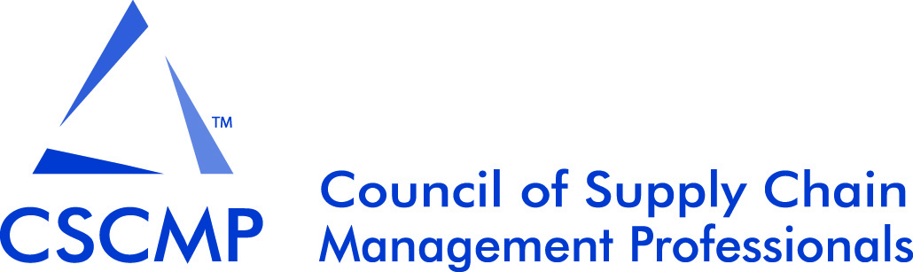

2017 Academic Research Symposium
Call for Papers and Panels
Atlanta, GA, USA
Sunday, September 24th, 2017
Submission Deadline: April 15th, 2017

The Academic Research Symposium (ARS) (formerly: Educators’ Conference) has earned a prominent reputation with many academics, as it is an excellent opportunity to meet colleagues and share new research for discussion and feedback. The ARS is proudly considered the premier event for research in supply chain management and logistics (SCML), and is an open event created to bring scholars from all disciplines into the SCML discussion.

The 2017 symposium will embrace research from all areas of business connected to SCML. The Conference Committee is excited to facilitate an event that will examine the past, present, and future innovations that continue to advance the discipline.

Manuscripts
Research submissions are encouraged in the form of: award competitive complete papers (~20 pages), summary abstracts (5 pages + figure), and developmental research abstracts (2 pages). All papers will be considered for two forms of presentation: live or poster sessions. Authors should be open to either form of presentation before submitting to the conference.

All research submissions will be evaluated on originality, clarity, research design, and theoretical and practical contribution. Desired topics connected to SCML include but are not limited to:

Big Data & Analytics | Human Capital/Talent Management | Quality Management
Base of Pyramid & Emerging Economies | Humanitarian Issues | Resource Planning
Behavioral Logistics & Operations | Information Systems & Technology | Retail Issues
Capacity Management, Planning & Analysis | Internal & External Integration | Reverse & Green Logistics
Circular Economy | International & Global Issues | Risk Management & Security Issues
Collaboration & Cooperation | Inventory Management | Service Operations
Complexity Issues | Lean & Agile Systems | Sourcing & Purchasing
Constraint Management | Location & Layout | Statistical Process Control
Coopetition | Manufacturing Issues | Strategy in the Supply Chain
Cost Management | Materials Management | Supplier Management
Customer Service | Metropolitan Area Issues | Supply Chains Beyond the Dyad
Environmental & Social Sustainability | Nearshoring/Reshoring/Insourcing | System Dynamics
Ethical Issues | New Methods in Research | Teaching Innovation
Financial Management | New Product/Service Development | Theory Development
Forecasting | Operations Management & Strategy | Transparency, Visibility, & Traceability
Healthcare Issues | Performance Management | Transportation Innovation
History of the Domain | Process Innovation & Optimization | Transportation Safety & Security

Only full-length award competitive research papers will be considered for the E. Grosvenor Plowman Award, which is awarded to the best research paper of the conference
Panels
The ARS Conference Committee is in search of suggested expert panels of academic and practioners. Contact richey@auburn.edu or any member of your ARS Conference Committee (see below) to propose your idea.

Pedagogy
The teaching innovation track also openly invites submissions, both full length or extended abstracts. These may include research papers on pedagogical techniques or methods, applied teaching case studies, innovative teaching methods, or experiential papers describing the use of new tools. Teaching submissions will be evaluated for originality, clarity, and value of discussion of learning outcomes. Papers submitted to the teaching innovations track will be considered for the Innovative Supply Chain Teaching Award.

Academic Research Symposium Conference Committee

Terry Esper - University of Arkansas – TEsper@walton.uark.edu
Areas of Expertise: (Pedagogy & Doctoral Symposium), Transportation Management, HRM in SCML, Corporate Citizenship, Relationship Conflict and Adaptation.

Ben Hazen – Air Force Institute of Technology – benjamin.hazen@afit.edu
Areas of Expertise: (Logistics), Sustainability, Big Data Analytics, Information Systems, Closed-loop Supply Chains and Circular Economy.

Glenn Richey – Auburn University – richey@auburn.edu
Areas of Expertise: (Conference Chair), Big Data & Technology, International SCML, Relationship Governance & Responsiveness, Reverse/Sustainable Logistics, Information Transparency, Disaster Recovery

Jeff Smith – Virginia Commonwealth University – jsmith74@vcu.edu
Areas of Expertise: (Operations Management), Service Recovery, Service Quality, Process Management, Healthcare Management

Beth Davis-Sramek – University of Louisville – beth.davis@louisville.edu
Areas of Expertise: (Pedagogy & Doctoral Symposium), Outsourcing/Offshoring, Retail SCM, Relationship Management, International SCML

Andreas Wieland – Copenhagen Business School – awi.om@cbs.dk
Areas of Expertise: (Supply Chain Management), Risk, Robustness and Resiliency, Social Responsibility, Complexity, Relationship Governance

George Zsidisin –Virginia Commonwealth University – gazsidisin@vcu.edu
Areas of Expertise: (Sourcing & Purchasing), Risk Assessment and Management, Supplier Relationships, Cost Control and Commodity Price Volatility, Corporate Social Responsibility in SCM, Theory Development and Application

Guidelines for Submissions
- All research track submissions must not have been published or accepted for publication in any journal or other outlet. To submit, simply attach an electronic copy of your submission to an e-mail directed to the conference chair, Glenn Richey ( richey@auburn.edu ). The conference committee will place all accepted research papers into appropriate research tracks according to primary topic. Papers that bridge multiple topic areas may be placed into the special cross-disciplinary presentation session.

- Submissions must be made following JBL style and formatting guidelines: http://onlinelibrary.wiley.com/journal/10.1002/(ISSN)2158-1592/homepage/ForAuthors.html.

- The first page of any submission should contain the manuscript’s title and complete author names, affiliations, and contact information. This first page will be dropped when the manuscript is sent out for review. The title should be repeated on the second page, which in turn should be followed by the abstract, body, and visuals.

- All submissions will undergo a double-blind review.

- Authors of accepted works will be asked to make appropriate changes based on reviewer comments for the conference proceedings prior to presentation and publication. Authors other than award winners will have an option to publish an abbreviated version in the proceedings.

- At least one author of each accepted research paper or abstract, and each teaching paper or abstract, must register for the ARS and agree to present their submission at the conference.

- Additional publishing assistance and suggestions may be found via JBL at http://dx.doi.org/10.1111/jbl.12039.

Authors will be notified on or before June 30th, 2017 as to the final decision regarding their submission’s acceptance to the conference.

For any additional information, please contact the 2017 CSCMP Academic Research Symposium Chair:
Glenn Richey, Harbert Eminent Scholar in Supply Chain Management, Auburn University, richey@auburn.edu

