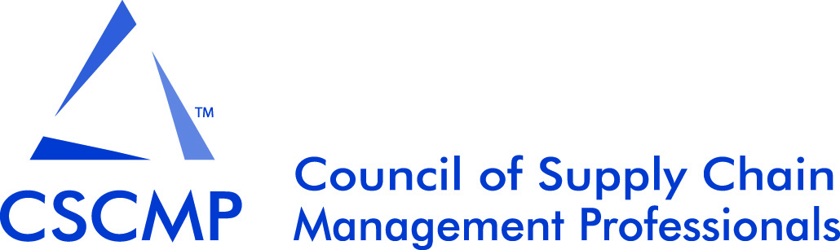

2016 CSCMP Educators’ Conference Call for Papers
Kissimmee, Florida, USA
Sunday, September 25, 2016
Submission Deadline: May 1, 2016 May 13, 2016

The Educators’ Conference has earned a prominent place with many academics, as it is an excellent opportunity to meet colleagues and share new research for discussion and feedback.

The 2016 conference will have four presentation tracks:

- Supply Chain Operations Management Track
Chair: Xen Koufteros, Jenna and Calvin R. Guest Professor in Business, Texas A&M University

- Supply Chain Logistics Track
Chair: Glenn Richey, Raymond J. Harbert Eminent Scholar and Professor in Supply Chain Management, Auburn University

- Purchasing and Supply Management Track
Chair: Craig Carter, Professor of Supply Chain Management, Arizona State University

- Teaching Innovation Track
Chairs: Donna Davis, Professor of Marketing, University of South Florida and Laura Meade, Professor of Supply Chain Practice, Texas Christian University

Two types of research submissions are encouraged: complete papers (20 pages) and extended abstracts (5 pages).

All research submissions (both papers and abstracts) will be evaluated on originality, clarity, research design, and theoretical and practical contribution. We are especially interested in receiving full papers describing work that spans the boundaries of supply chain management’s various sub-disciplines, (i.e., logistics and transportation, operations, and purchasing) though work that resides primarily within the scope of only a single discipline will also be welcomed. Only full-length research papers will be considered for the E. Grosvenor Plowman Award, which is awarded to the best research paper of the conference. Extended research abstracts are also welcomed, but priority in the final program will be given to full-length papers, and space for abstracts could therefore be limited.

New for 2016, abstracts of early development research (an extended abstract of 5 pages) will be considered for poster sessions held during the conference breaks in the break area as well as in the Supply Chain Exchange during the Managers Conference. This will allow for networking and feedback on the research with both scholars and practitioners!

The teaching innovation track also openly invites submissions, both full length or extended abstracts. These may include research papers on pedagogical techniques or methods, applied teaching case studies, innovative teaching methods, or experiential papers describing the use of new tools. Teaching submissions will be evaluated for originality, clarity, and value of discussion of learning outcomes. Papers submitted to the teaching innovations track will be considered for the Innovative Supply Chain Teaching Award.

Guidelines for submissions:
- All research track submissions must not have been published or accepted for publication in any journal or other outlet. To submit, simply attach an electronic copy of your submission to an e-mail directed to the conference chair, Susan Golicic (susan.golicic@business.colostate.edu). Unless a specific request is made, the conference committee will place all accepted research papers into one of the three research tracks, according to primary topic. Two to three integrated papers will be considered for presentation in a general session (new for 2016). Special requests for placement can be made, and will be handled on an individual basis.

- Authors of teaching innovation submissions should indicate in the email message that their paper is intended for the teaching innovation track. These submissions should be sent directly to one of the chairs of the teaching innovation track, Donna Davis or Laura Meade (donnadavis@usf.edu or l.meade@tcu.edu).

- Submissions must be made following JBL style and formatting guidelines: http://onlinelibrary.wiley.com/journal/10.1002/(ISSN)2158-1592/homepage/ForAuthors.html

- The first page of any submission should contain the manuscript's title and complete author names, affiliations, and contact information. This first page will be dropped when the manuscript is sent out for review. The title should be repeated on the second page, which in turn should be followed by the abstract, body, and visuals.

- All submissions will undergo a double blind review.

- Authors of accepted works will be asked to make appropriate changes based on reviewer comments for the conference proceedings prior to presentation and publication. Authors other than award winners will have an option to publish an abbreviated version in the proceedings.

- At least one author of each accepted research paper or brief, and each teaching paper or brief, must register for the Educators’ Conference and agree to present their submission at the conference.

Authors will be notified on or around June 15, 2016 as to the final decision regarding their submission’s acceptance to the conference.

For any additional information, please contact the 2016 CSCMP Educators’ Conference Chair:

Susan Golicic, Herbert Family Research Fellow and Associate Professor of Supply Chain Management, Colorado State University susan.golicic@business.colostate.edu



