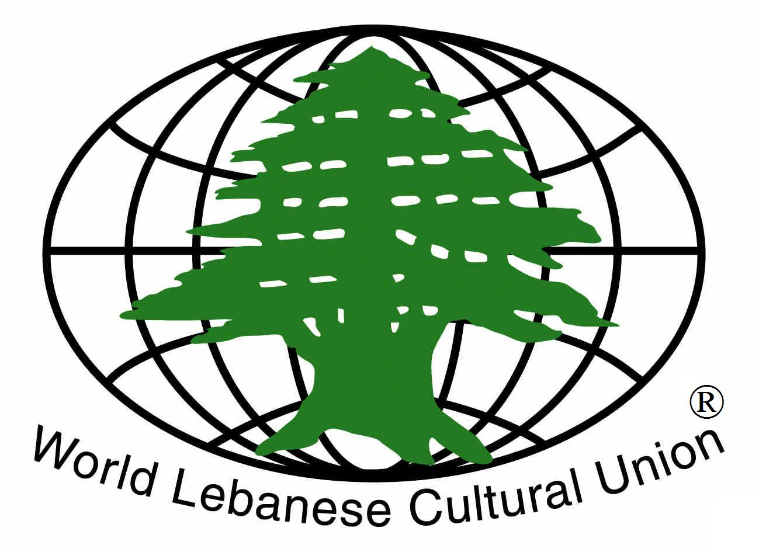

The World Lebanese Cultural Union – Greater Boston Chapter

Presents

A 125th Anniversary Celebration of the Birth of
Khalil Gibran


“The Enduring Legacy of Khalil Gibran”
by Professor Suheil Bushrui
University of Maryland &
Director of the Khalil Gibran Chair for Values and Peace

Followed By Dance Performances With

Wendy Jehlen

Founder/Artistic Director - Anikai Dance Company

“On Beauty”

WLCU Youth Dabke Dance Group
“Lebanese Folkloric Dance”



Thursday, December 4, 2008
6 pm - 8:30 pm

Boston Public Library
700 Boylston Street, Copley Square
Boston, MA 02116

Free and Open to the Public

