Dear MIT Friends & Neighbors,

We are residents of Simmons Hall, one of MIT’s undergraduate dormitories.

This year our undergraduate residents have decided to continue an old Simmons Hall tradition: hosting a Halloween open house for the children of the MIT Community.

The attached poster describes the event, which is scheduled for Saturday, October 26th, from 2 to 5 pm.

The event is free and suitable for young children, aged 6 and below. Older siblings are welcome, but should understand that this event will focus on young children.

We will feature activities that should be able to keep your child occupied for about 30 to 60 minutes, age dependent.

If you have questions, please contact Ellen, Josh or Allen by e-mail.

We hope that you and your children will help Simmons Hall celebrate Halloween!

Best,
Ellen M. Essigmann (emessig@mit.edu)
John M. Essigmann
MIT Faculty Residents, Simmons Hall

Josh Gonzalez (jogon_1@mit.edu)
Area Director, Simmons Hall
MIT Division of Student Life

Allen Park ’15 EECS (allenpark@mit.edu)
Social Chair, Simmons Hall

Attached: Event Poster
Halloween Open House!
What: Join the residents of Simmons Hall for what we think is the best Halloween children’s event @ MIT.

The event is free and includes:
        - Halloween-themed arts and crafts.
        - Halloween-themed activities.
        - Halloween-themed movies.
        - Photo portraits.
        - Refreshments for children and adults.

When: Saturday, October 26th, from 2 to 5 PM

Where: Simmons Hall @ 229 Vassar Street

For young children, aged 1 to 6 years, and parents!
Costumes welcome, but not required.
Treat bags will be provided.

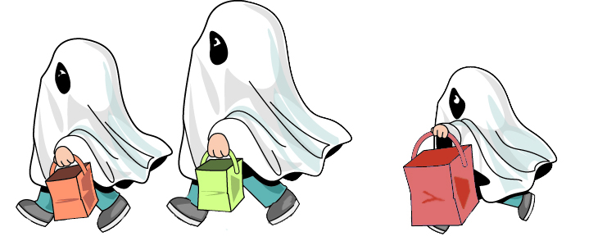

Note: Children must be accompanied by a responsible adult at all times.

