

GAME NIGHT!!





What: LCC, BSU, LBGT Mixer

When: Sunday Nov 12th 5:30 pm – 7:00 pm

Where: LCC Lounge (Student Center Basement)



GAMES
FREE FOOD



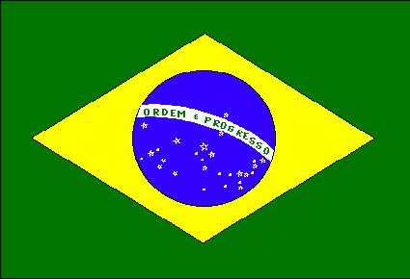







Why: Because there will be socializing,
games, and especially…

FREE FOOD!!!!

ALL ARE
WELCOME!!

