

LIBRETTO: BECAUSE WORDS STILL MATTER
WHAT WE DO
Strategic messaging → Content development

The company specializes in:
- Messaging and communications consulting – Messaging platforms (key messages, brand attributes, elevator pitches), communication plans and audits, and strategies for integrating online and offline communications
- Naming and branding services – Company names, product names, campaign themes, and taglines
- Print and multimedia – Advertising, viewbooks, fundraising materials, promotional collateral, annual giving campaigns, multimedia presentations, and direct marketing
- Websites – Content development, content strategy, and information architecture

THE LIBRETTO TEAM
Libretto is made up of a team of senior content developers and strategists. We collaborate closely with leading design, communications, and interactive firms.
Some Recent Clients
Babson College
Boston Symphony Orchestra
Clark University
The Earth Institute at Columbia University
Huntington Theatre Company
ING Financial Services
Loyola College of New Orleans
MIT
Palm Restaurant Group
Partners in Health
RSA Security
LIBRETTO + MIT
Our team of strategists and writers has extensive experience in the field of higher education, and with MIT in particular; since 1999 we have created a wide range of print and online materials – and delivered communications consulting and naming services – for more than 30 MIT clients, including academic departments, research labs, strategic initiatives, and Institute offices and services.

The diverse types of projects we’ve completed for MIT include:
- campaign names and themes
- messaging platforms
- websites
- viewbooks
- brochures
- articles
- development materials

These materials are targeted at diverse internal and external audiences of great strategic value to MIT, such as current and prospective students and parents, alumni, industry, and other research and educational institutions. Much of the content we create is extremely technical; we work closely with many of MIT’s prestigious researchers and innovators – including Robert Langer, Tim Berners-Lee, Paula Hammond, Linda Griffith, and Victor Zue – to understand and clearly articulate the details and impact of their work for the appropriate audience.

Libretto MIT Clients

- Office of Admissions
- Aga Kahn Program for Islamic Architecture
- ArchNet
- Arts@MIT
- Department of Brain and Cognitive Sciences
- Office of Campus Dining
- Center for Real Estate
- Center for Work, Family and Personal Life
- Department of Chemical Engineering
- Computer Science & Artificial Intelligence Laboratory
- Education Studies Program
- School of Engineering
- Entrepreneurship Center
- Environment, Health and Safety Office
- The Human Factor capital campaign (see next page)
- Human Resources
- Information Services & Technology
- David H. Koch Institute for Integrative Cancer Research
- Laboratory for Information and Decision Systems
- Lemelson-MIT Awards
- Madrid-MIT M+Visión Consortium
- Department of Mechanical Engineering
- MIT10⁵: Powers of Participation
- MIT 150/Open House
- MIT Donor Society
- MIT Global Initiative
- MIT LGO
- MIT Medical
- MIT-Microsoft Alliance
- MIT Museum
- Operations Research Center
- Residential Life and Student Life Programs
- Singapore-MIT Alliance
- Sloan School of Management
- Student Support Services (S3)
- UPOP (Undergraduate Practice Opportunities Program)
- Whitehead-MIT BioImaging Center

INVENTIONAL WISDOM

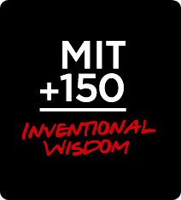

Libretto created Inventional Wisdom, MIT’s 150th anniversary theme.
THE HUMAN FACTOR

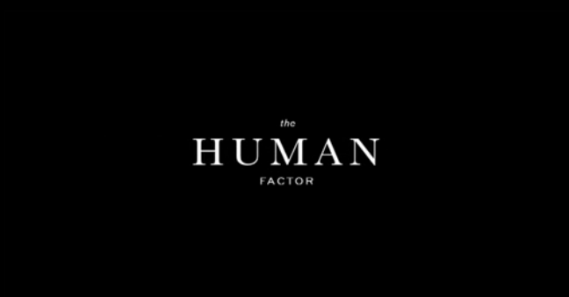

Libretto named this $500 million fundraising initiative, which was intended to address a broad range of student-centered activities, from scholarships and fellowships to programs focused on athletics and public service. We also developed a brochure for the campaign and a preview book for potential major donors that included several student profiles expressing the need for financial support.
The Deshpande Center for Technological Innovation

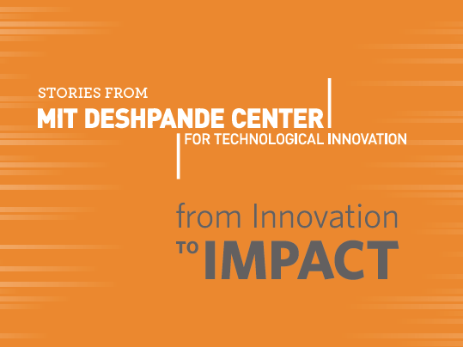

Libretto developed a book highlighting recent projects funded by the Deshpande Center. Our work included content strategy, interviews, and writing. The project, which debuted at a recent event, has been very well received.

