FOR IMMEDIATE RELEASE

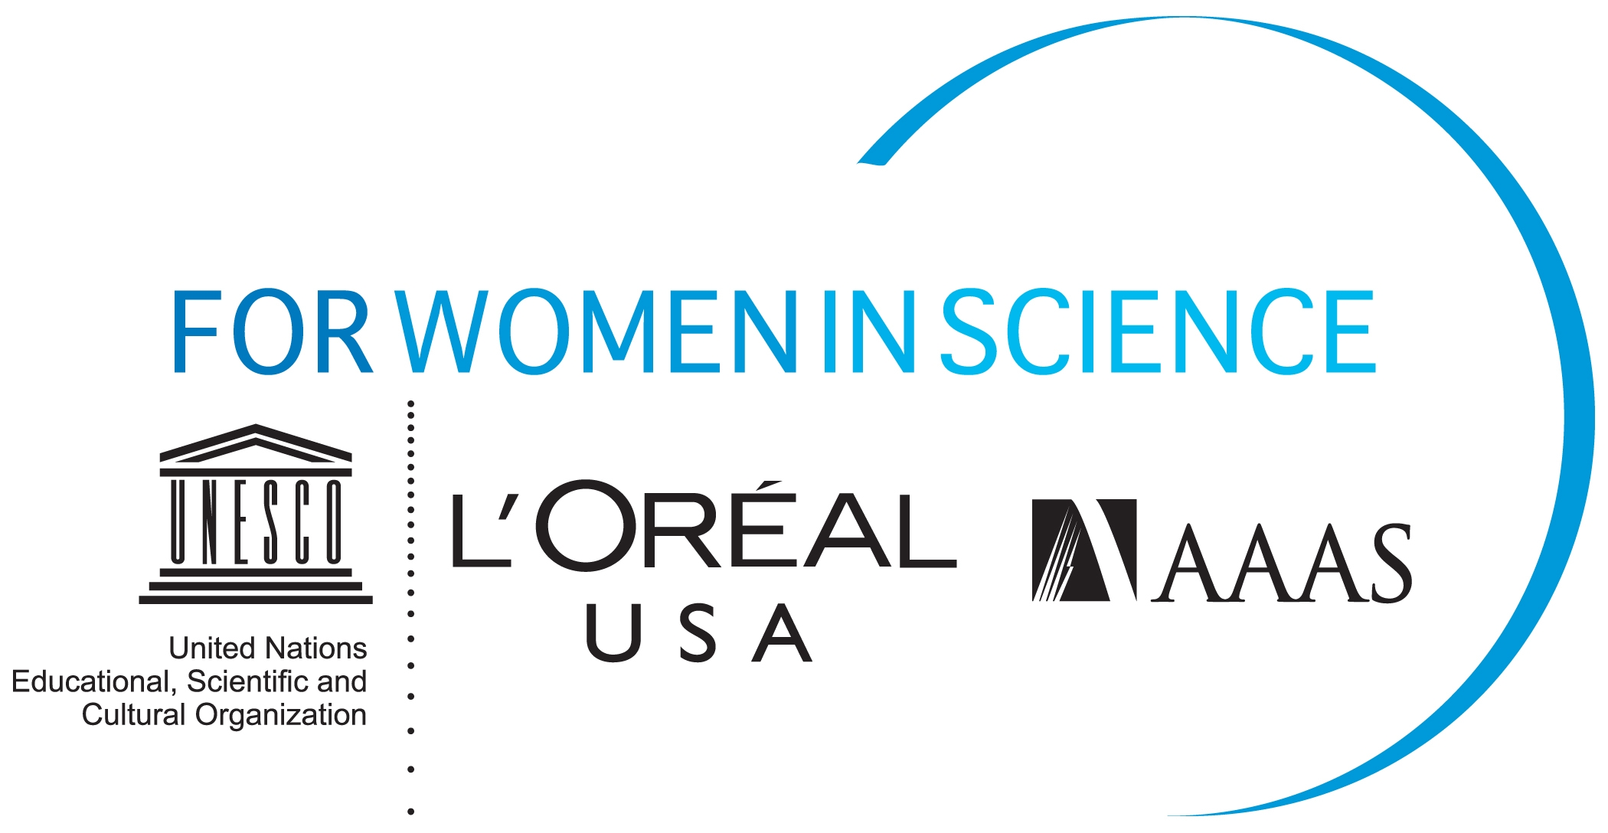

L’ORÉAL USA ANNOUNCES CALL FOR APPLICATIONS FOR
2011 FELLOWSHIPS FOR WOMEN IN SCIENCE PROGRAM

Fellowship grants help women shape the future of science

NEW YORK, NY, November 1, 2010 – L’Oréal USA announced today the start of the application period for its esteemed L’Oréal USA Fellowships For Women in Science program. Now entering its eighth year, this national program annually recognizes, rewards and provides support to five women postdoctoral researchers in the U.S. who are pursuing careers in the life and physical/material sciences, as well as mathematics, engineering and computer science. As part of L’Oreal’s commitment to further help women scientists achieve their goals, L’Oréal USA awards each recipient up to $60,000 to apply toward their postdoctoral research.

Since its inception in 2003, the L’Oréal USA Fellowships For Women in Science program has awarded 35 fellowships to women scientists across the U.S. Each year, the program attracts a number of talented applicants from diverse scientific fields, representing some of the nation’s leading academic institutions and laboratories. A distinguished jury of nine eminent scientists reviews the applications and selects the L’Oréal USA Fellowships For Women in Science recipients.

The five beneficiaries of the 2011 L’Oréal USA Fellowships For Women in Science program will be invited to attend a week of events that include an awards ceremony, professional development workshops, media training and networking opportunities. In 2011, these workshops, which are facilitated by the American Association for the Advancement of Science (AAAS), will encompass job search techniques, interviewing skills, budget development for grant requests and strategies for peer-reviewed publication.

The L’Oréal USA Fellowships For Women in Science program is open to women postdoctoral researchers only. Candidates interested in applying may visit the L’Oréal USA Fellowships For Women in Science website at http://www.lorealusa.com/forwomeninscience to obtain more information about program eligibility and requirements. Applications must be submitted online by December 13, 2010 and transcripts must be postmarked no later than December 15, 2010.

The L’Oréal USA Fellowships For Women in Science program complements the international L’ORÉAL-UNESCO For Women in Science program which annually awards $100,000 to each of five leading women career scientists; one from Europe, Asia, North America, South America and Africa. In addition, the UNESCO-L’ORÉAL International Fellowships annually grants, over a two year period, up to $40,000 each to 15 promising young women scientists from around the world, at the doctoral or postdoctoral levels.

-- more –

The L’Oréal USA Fellowships For Women in Science program and its aim to advance the careers of women postdoctoral researchers in the U.S., is especially relevant in light of America’s waning competitiveness in the global marketplace. There is an urgent need to increase both the funding for basic science research in the U.S. and also the number of students, particularly girls and young women, majoring in science, mathematics and engineering.

Earlier this year, L’Oréal USA commissioned a national survey, fielded by the American Association for the Advancement of Women in Science (AAAS), of 1,300 male and female scientists. This survey exposed the insurmountable barriers women encounter in the pursuit of scientific careers. Survey respondents included male and female scientists who hold doctoral degrees and are registered users of Science online, including members of AAAS. The survey revealed:

- Nearly all female scientists (98 percent) know a female colleague who left the science field because
she encountered barriers to her professional success
- More than half of female scientists (52 percent) have experienced gender bias during their career
- More than one in three female scientists (37 percent) faced barriers in having/raising children

L’Oréal understands the need to attract more women to science. In developing programs such as the L’Oréal USA Fellowships For Women in Science, L’Oréal’s goal is to support today’s women scientists, develop female role models for generations to come, and help shape the public’s perception of science in a positive light, particularly among young women.

For more information, please visit: http://www.lorealusa.com/forwomeninscience

ABOUT L’ORÉAL
A worldwide leader in the cosmetics industry, L’Oréal develops innovative products to meet the diverse needs of customers in 130 countries worldwide. Nearly 3,000 people work in the Group’s 16 research centers, located in France, Asia and America. Their findings are responsible for the registration of hundreds of patents annually. Women represent 55% of the research workforce – a percentage unmatched anywhere else in the industry. www.loreal.com

ABOUT AAAS
The American Association for the Advancement of Science (AAAS) is the world’s largest general scientific society, and publisher of the journal, Science (www.sciencemag.org) as well as Science Translational Medicine (www.sciencetranslationalmedicine.org) and Science Signaling (www.sciencesignaling.org). AAAS was founded in 1848, and includes some 262 affiliated societies and academies of science, serving 10 million individuals. Science has the largest paid circulation of any peer-reviewed general science journal in the world, with an estimated total readership of 1 million. The non-profit AAAS (www.aaas.org) is open to all and fulfills its mission to “advance science and serve society” through initiatives in science policy; international programs; science education; and more. For the latest research news, log onto EurekAlert!, www.eurekalert.org, the premier science-news Web site, a service of AAAS.

ABOUT UNESCO
Since its creation in 1945, UNESCO has been dedicated to eliminating all forms of discrimination and promoting equality between men and women. While designing scientific education programs intended especially for young women, UNESCO has created several academic chairs that connect women of science around the world. With 191 Member States, UNESCO functions as a laboratory of ideas and a standard-setter to forge universal agreements on emerging ethical issues. UNESCO works to create the conditions for true dialogue, based upon respect for commonly shared values and the dignity of each culture. www.unesco.org

For more information please contact:
L’ORÉAL USA

Virginia Niz
Tel: +1-212-984-4474
vniz@us.loreal.com

