Are you ready for a change?
Do you have a point of view on world events?
Are you ready to carry that message forward?

Join us and wear a message of peace and sanity during dangerous times.
Reason8 shirts carry messages with political commentary about society as we find it.

Politics as Fashion = Fashion as Politics
Reason8 designs and produces Fair Fashion: our clothes are never made in a sweatshop.

Check out our collection at http://www.reason8.net
[Our "One Nation Under Surveillance" shirt/closeup, shown below.]

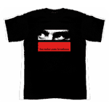
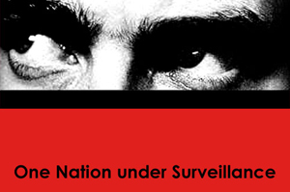

We want to s p r e a d far and wide, we want our messages to reach everyone, we want everyone wearing these shirts — help us achieve these humble goals!

If you can — send this to your friends — and ask them to send it to theirs. We could reach every right- (left) thinking computer in the country...

From now until Election Day, 10% of all Reason8 web sales (not just profits) will go to MoveOn.org. We believe we can make a difference in what happens this November!

Hey, it's our world . . . let's change it!

Peace/dream
From the gang at r8
resonate!

