The Twelve Girls Band
Live In Concert

Berklee Performance Center
136 Massachusetts Ave., Boston MA

Date: Thursday, October 13, 2005

Time: 8:00 pm

Tickets available through Ticketmaster or Ticketmaster.com

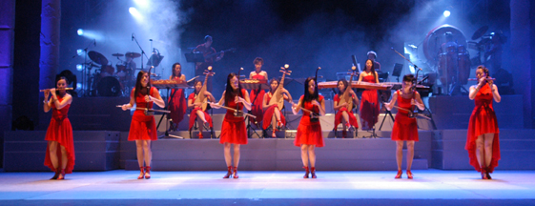

Twelve Girls Band
Berklee Performance Center
Oct. 13, 8PM
http://www.berkleebpc.com/calendar.html#October
http://www.twelvegirlsband.com
http://launch.groups.yahoo.com/group/12girlsband
Twelve Girls Band
Berklee Performance Center
Oct. 13, 8PM
http://www.berkleebpc.com/calendar.html#October
http://www.twelvegirlsband.com
http://launch.groups.yahoo.com/group/12girlsband
Twelve Girls Band
Berklee Performance Center
Oct. 13, 8PM
http://www.berkleebpc.com/calendar.html#October
http://www.twelvegirlsband.com
http://launch.groups.yahoo.com/group/12girlsband
Twelve Girls Band
Berklee Performance Center
Oct. 13, 8PM
http://www.berkleebpc.com/calendar.html#October
http://www.twelvegirlsband.com
http://launch.groups.yahoo.com/group/12girlsband
Twelve Girls Band
Berklee Performance Center
Oct. 13, 8PM
http://www.berkleebpc.com/calendar.html#October
http://www.twelvegirlsband.com
http://launch.groups.yahoo.com/group/12girlsband
Twelve Girls Band
Berklee Performance Center
Oct. 13, 8PM
http://www.berkleebpc.com/calendar.html#October
http://www.twelvegirlsband.com
http://launch.groups.yahoo.com/group/12girlsband
Twelve Girls Band
Berklee Performance Center
Oct. 13, 8PM
http://www.berkleebpc.com/calendar.html#October
http://www.twelvegirlsband.com
http://launch.groups.yahoo.com/group/12girlsband
Twelve Girls Band
Berklee Performance Center
Oct. 13, 8PM
http://www.berkleebpc.com/calendar.html#October
http://www.twelvegirlsband.com
http://launch.groups.yahoo.com/group/12girlsband

