Dimagi/CIDRZ Group

Intent
We are developing the process that would facilitate the use of mobile device to transport images taken by nurses at health care centers (point-of-care) in rural Zambia to a server in Lusaka where doctors can access the images in order to provide expert advice on cervical lesions. We would like to explore the use of this approach to facilitate a scalable national cervical cancer screening program. Finally, we would like to design a platform that would allow transfer of the images directly to an electronic medical record database for archiving.

Background
Cervical cancer is a leading cause of death from cancer among women in resource-poor countries, affecting women at a time of life when they are critical to social and economic stability [1]. Its rise in prevalence over the last decade is a direct consequence of the spread of HIV in the region. Transmission of the human papilloma viruses that cause cervical cancer is facilitated by the presence of HIV infection. In addition, progression of cervical dysplasia is accelerated by immunosuppression that results from an advancing HIV infection. Cervical cancer is one of the few cancers with a long preclinical phase. A screening program aimed at detecting and treating precancerous lesions reduce the number of cases that require treatment. This is the basis for annual Pap smar screening that is routine in most developed countries. However, this approach requires established laboratories, highly-trained cytologists, and up to 3 visits per screening (Pap smear, + colposcopy, treatment), and is not feasible in resource-poor countries. Single visit "screen-and-treat" approach using visual inspection with 4% acetic acid (VIA) and early treatment with cryotherapy has been shown to feasible and effective in reducing cervical cancer incidence and mortality [2-4]. In a study by the Harvard School of Public Health, screening of women with one-visit visual inspection at about 35 years of age would reduce the lifetime risk by 25 to 36 percent [5]. Two screenings in a lifetime would provide a relative increase in the lifetime reduction of risk of cancer of approximately 40 percent, but obviously at a higher cost.
The Center for Infectious Disease Research in Zambia (CIDRZ) has been providing HIV prevention and treatment services since 2004. For this project, CIDRZ has partnered with Dimagi, an organization that provides technological solutions to problems in the developing world, to design and implement a national cervical cancer screening program. Given that diagnostic and therapeutic expertise in cervical malignancy is scarce and localized in Lusaka, a nationwide screening using the traditional approach of performing Papnicolau smear is out of the question. The use of visual inspection with 4% acetic acid (VIA) and early treatment with cryotherapy by rural nurses has been implemented in a number of locations, with quality assurance provided by Lusaka-based specialists.

Current Landscape
CIDRZ currently has deployed the cervical cancer screening system just described in 4 clinics outside of Lusaka. Images are taken primarily for quality assurance and quality improvement purposes. Real-time decision support where indeterminate lesions can be reviewed by specialists is not available due to file size issues in GPRS emails. Also for this reason, quality assurance is provided by specialists who physically travel to the clinics once a week to review the images with the nurses. This process is not scalable given the resource constraints.

Aims and Key Deliverables
The aim is to develop an application that uses camera on device, captures image, resizes and transmits to an off-site specialist for decision support and QA/QI purposes. The system that will be developed will be used to scale cervical cancer screening to the rest of Zambia. We plan on leveraging the JavaRosa project for Open Source mobile XForm development. This software is compatible with the pilot hardware, the Nokia E90 and provides a robust, flexible framework for rapid development of survey tools. The image is transmitted with basic patient and clinical information to the central server. The central server will be located at the CIDRZ office in Lusaka.

Prior to the pilot implementation, we shall come up with a scoring system that will help the nurses classify the cervix after VIA as either positive or negative. Ideally, five features will be graded. Recommended cut-off scores for positive, indeterminate and negative cervix will help standardize assessment.

For the next phase, we will design a platform for information management by the central server. In this platform, the images and relevant clinical information is accessible in a real time manner off a standard web browser via the internet. It shall provide capabilities for progress note entry by and communication between the nurses at the point-of-care and off-site specialists. Additional features of this web portal will include a personalized inbox for nurses and doctors to manage images under their care, a simple patient tracking system to allow for rapid retrieval of a patient’s image history, and a rich markup system to annotate relevant metadata on a patient’s image for retrieval at a later time. We will explore methods that will provide integration that would allow our application to support HL7, facilitating interface with other health information systems.

Insuring Sustainability
As Professor Ken keniston pointed out, demonstrating value for ICT4D projects is key in order to insure sustainability. Value is defined by the outcomes achieved divided by the cost of achieving those outcomes. Interventions to address specific societal needs should undergo rigorous and robust evaluation especially when there are limited resources, whether economic or human. The use of expensive technology should be justified by value, not by its ingenius design and demonstration of its feasibility. It has to facilitate the most cost-effective way of achieving the desired outcomes and the delivery of the best return-on-investment.
In collaboration with the Zambia Ministry of Health, CIDRZ, Dimagi and the Harvard School of Public health, we are planning to perform cost effectiveness analysis of our technology-facilitated national cervical screening program through mathematical modeling. This will require information including the cost of implementation of the technology, outcomes tracking (cervical cancer incidence and mortality) as well as data that are already available from other countries that are demographically similar to Zambia (e.g. natural history of cervical cancer, patterns of sexual behavior, risk factors for cervical cancer, cost of treatment of advanced cervical cancer). It is important to note, however, that cost information differs between countries,and country-specific data are preferable as much as possible. This analysis will allow us to calculate the cost per year of life saved, and depending on a country's cut-off for what it considers cost-effective (usually less than the per capita GDP according to the Commision on Macroeconomics and Health [6]), will determine whether the project delivers a good return-on-investment. Such an analysis will also help us in optimizing parameters such as frequency of screening during lifetime, and the age of women who should be targeted for screening. The traditional screen-and-treat approach using VIA, for example, was shown to be most cost-effective in 5 resource-poor countries when performed once or twice in a lifetime to women between the ages of 35 and 45 years. Whether this finding is valid as well for our mobile device-facilitated approach remains to be seen.
Rigorous and robust analyses of ICT4D projects, such as the one we are hoping to perform, can provide guidance for the global community by identifying health investments that are of the highest priority and have the greatest promise.
Technological Architecture
User case. The nurses will be collecting data in the form of text describing medical information as well as images of patients. The data will be collected using a camera phone that will then send the information to a server via GPRS. Doctors, once alerted via SMS and/or MMS, will access the data on the server to review the case and call the on-site nurse on her cell phone. Here is a diagram that summarizes this:

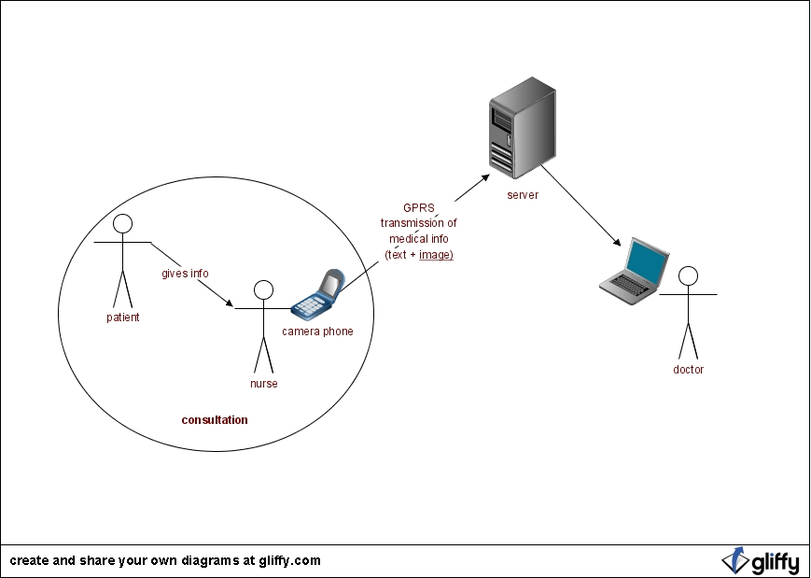
Architecture. The solution is based on J2ME midlet running on a N90 Nokia phone. The midlet will access the camera of the phone and will let the user enter text data. The data will be collected using a XForm if it's possible to easily integrate images in there. The web application will receive the data and store it into a RDBMS such as MySQL to then render it to the end user on a web browser. The user will use the web interface to anotate people's records and send that information back to the nurses as well as share it with other doctors. The server will run on either LAMP (Linux, Apache, MySQL, PHP) or something more standard for data collection such as ORBEON.
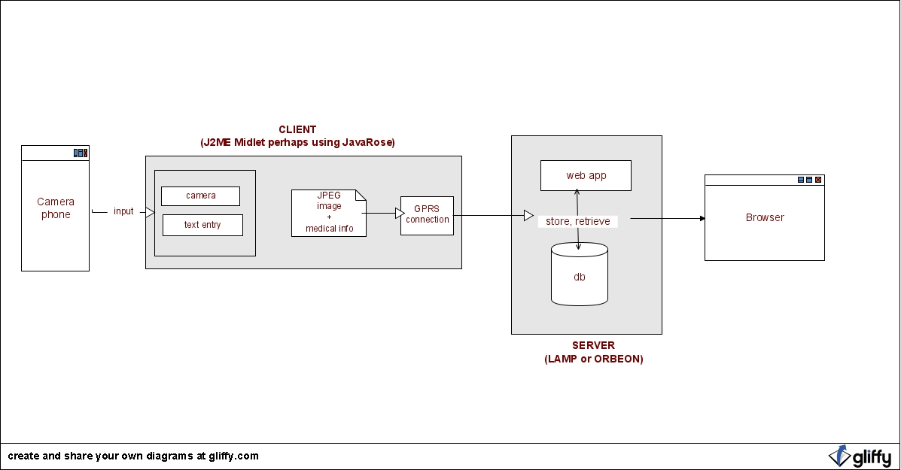
The Workflow
The nurse obtains the following clinical information from the patient, and then prepares the patient for a speculum examination.
A cervix that is grossly abnormal does not require painting with 4% acetic acid. Images are taken and either the patient is treated with or without real-time decision support, or referred to the hospital. Normal looking cervices are painted with 4% acetic acid, then classified after visual inspection as either negative, indeterminate or positive. Images of indeterminate cases are transmitted for review by off-site specialists.

The images are transmitted to the server accompanied by the clinical information obtained from the patient.

Once the image and clinical information are received by the server, the on-call doctor is alerted that an image needs to be reviewed either by SMS and/or MMS. After reviewing the image, the off-site doctor contacts the on-site nurse by cell phone to discuss the image and the patient. The cervix is classified as either VIA-negative or positive. Lesions that are positive by VIA may either be treated on-site or referred to a tertiary hospital. The final impression after discussion is entered into the server by the doctor through a web portal. In the next phase of the project, the doctor will have a software on his cell phone that will allow him to enter the final impression and recommendation to the server.
Patients who receive treatment on site with either liquid nitrogen or antibiotics will be required to follow-up. Follow-up images and clinical information will be sent to the central server. This is an important step for quality assurance/quality improvement. However, we are aware that there is a significant number of patients that are lost to follow-up.

Internet and GPRS Providers
Addressing Privacy Issue
Patients are assigned a unique identifier at the health center. This information is stored and can only be accessed locally. The images and clinical information are labelled with the patient's unique identifier both for transmission and for storage at the central server. Patient names are not important during the regular quality assurance/quality improvement meetings. For follow-ups done locally, the nurse will be able to "link" the images from the locally-stored relational database. For patients who are referred to the hospital in Lusaka, a letter with the patient's unique identifier will be given to the patient in case the Lusaka specialists would like to access the prpevious images from the central server.
Quality Assurance/Quality Improvement
Quality assurance and quality improvement will be done through periodic reviews of all the images that have been transmitted. The platform for these regular QA/QI meetings has not been decided yet.
Metrics that will be tracked during implementation include:
- Process Metrics:
1. Number of images transmitted that were deemed suboptimal requiring the image to be re-taken and re-sent
2. Number of images that did not go through for technical reasons
3. Time it takes for the on-call specialist to get back to the nurse with his input
- Outcome Metrics
1. Number of images sent per nurse per week that require specialist input
2. Number of cases where diagnosis was deemed inaccurate after review during the QA/QI process or in retrospect during follow-up

Operational and Technical Risks
The most important operational risk is the reliability of the cellular and internet infrastructure. Power failures are likewise common in Zambia and pose another serious operational risk as internet connectivity is tied to power. Back-up with GPRS modem is thus necessary.
Work Plan

Element | Action | Time line
Requirements | Collect information about people using the system as well as the state of cellphone access in Zambia | End of March
Client prototype | Able to send data to server along with an image and text | Mid April
Server prototype | Able to receive data from a client that includes image and text | Late April
Testing | Iteration between testing and development | Early May

Research and Development Team
Andrés Monroy-Hernández, software engineer, client-side
Daniel Myers, software engineer, server-side
Leo Anthony Celi, medical consultant
Daniel Myung, project adviser
Gari Clifford, project adviser

References:
1. Ferlay J, Bray F, Pisani P, Parkin DM. GLOBOCAN 2000: cancer incidence, mortality and prevalence worldwide, version 1.0 IARC Cancerbase no. 5, Lyon, France: IARC Press, 2001.
2. Sankaranarayanan R, Esmy PO, Rajkumar R, Muwange R, Swaminathan R, Shanthakumari S, Fayette JM, Cherian J. Effect of visual screening on cervical cancer incidence and mortality in Tamil Nadu, India: a cluster-randomised trial. Lancet 2007;370:398-406.
3. Denny L, Kuhn L, De Souza M, Pollack AE, Dupree W, Wright TC. Screen-and-treat approaches for cervical cancer prevention in low-resource settings: A randomized controlled trial. JAMA 2005;294(17):2173-81.
4. Brewster WR, Hubbell FA, Largent J, Ziogas A, Lin F, Howe S, Ganiats TG, Anton-Culver H, Manetta A. Feasibility of management of high-grade cervical lesions in a single visit. JAMA 2005;294(17):2182-87.
5. Goldie SJ, Gaffikin L, Goldhaber-Fiebert JD, Gordillo-Tobar A, Levin C, Mahe C, Wright T for the Alliance for Cervical Cancer Prevention Cost Working Group. Cost-effectiveness of cervical cancer screenin gin five developing countries. NEJM 2005;353(20):2158-68.
6. World Health Organization. Macro-economics and health: investing in health for economic development: report of the Commission on Macroeconomics and Health. Geneva: World Health Organization, 2001.

Appendix A. Needs Assessment

Who is the target population?
- Nurses in rural (possibly some urban as well) areas of Zambia that do cervical cancer screening.
- Doctors reviewing the images. Doctors in the US might be recruited to help out to improve turn-around time for decision support.
- There is a possibility that health care workers will be recruited once the project is scaled nationally.
- Number of doctors, nurses +/- HCW's unknown
What demographic data do we need?
- Usual demographics (age, sex, work location)
- For nurses, RN or LPN?
- Highest educational level of HCW
- Are they salaried or volunteers?
- Are they part-time or full-time?
  - CHW look to be fulltime, from my vantage point, still awaiting more detailed information from CIDRZ
What infrastructure (physical and human) information would help you design your project/product?
- What areas are we trying to cover?
  - National deployment. Phased out initially at CIDRZ sites, hopefully to the farthest reaches of the country.
  - Afterwards, seek to make it a standard for treatment in Sub-Saharan Africa
- Coverage of MMS and GPRS/CDMA. Which carrier to use?
  - Celtel. Widest coverage. Was told that any voice coverage will have GPRS. Most clinics will most likely have basic cell coverage, in reality not so, but for pilot this is ok.
- Where will the server be? Hospital or CIDRZ headquarters? Do they already host server there?
  - CIDRZ will host the central server. They have the infrastructure to do so, but will need to dedicate a machine for this.
- Internet connectivity between carrier and server
  - Still ongoing, celtel will be able to route its data effectively internal to the Celtel network, getting direct access to CIDRZ may not be the scope of this project.
- Are there technical people to provide support to the users and to do server maintenance?
  - This is still up for discussion. Dimagi will probably be in some sort of service contract for this as well as provide handoff of knowledge for local staff.
- Power availability
  - A serious consideration since internet is tied to power. Backup with GPRS modem looks to be a must.
- Current workflow of doctors, nurses, health care workers
What beliefs, opinions, and practices would affect utilization of your project/product?
- Privacy concerns
- Comfort with technology (nurses +/- HCWs -> cameras, doctors -> computers)
- Relationship between nurses and doctors, including level of trust. Are there issues that need addressing? Success will be influenced by degree of teamwork.
  - Rapport between current crop of nurses and docs is great, trust and respect on both sides for medical diagnoses and such is strong.

Appendix B. Clinical Information accompanying Images
1. Date and time stamp
2. Patient ID number
3. Clinic location
4. Practitioner ID
5. Age
6. Year of last screening
7. HIV status
a. Positive
b. Negative
Date last tested
c. Not tested
8. ARV status
a. On ARV
b. Not on ARV
9. CD4 count
a. <100
b. 100-200
c. >200
10. Gynecologic history
a. Previous cervical lesion
Yes
Infection
Tumor
Unclear
Others
No
b. Previous treatment for cervical lesion
antibiotics
liquid nitrogen
others

