**Tips for a Successful Blood Donation**

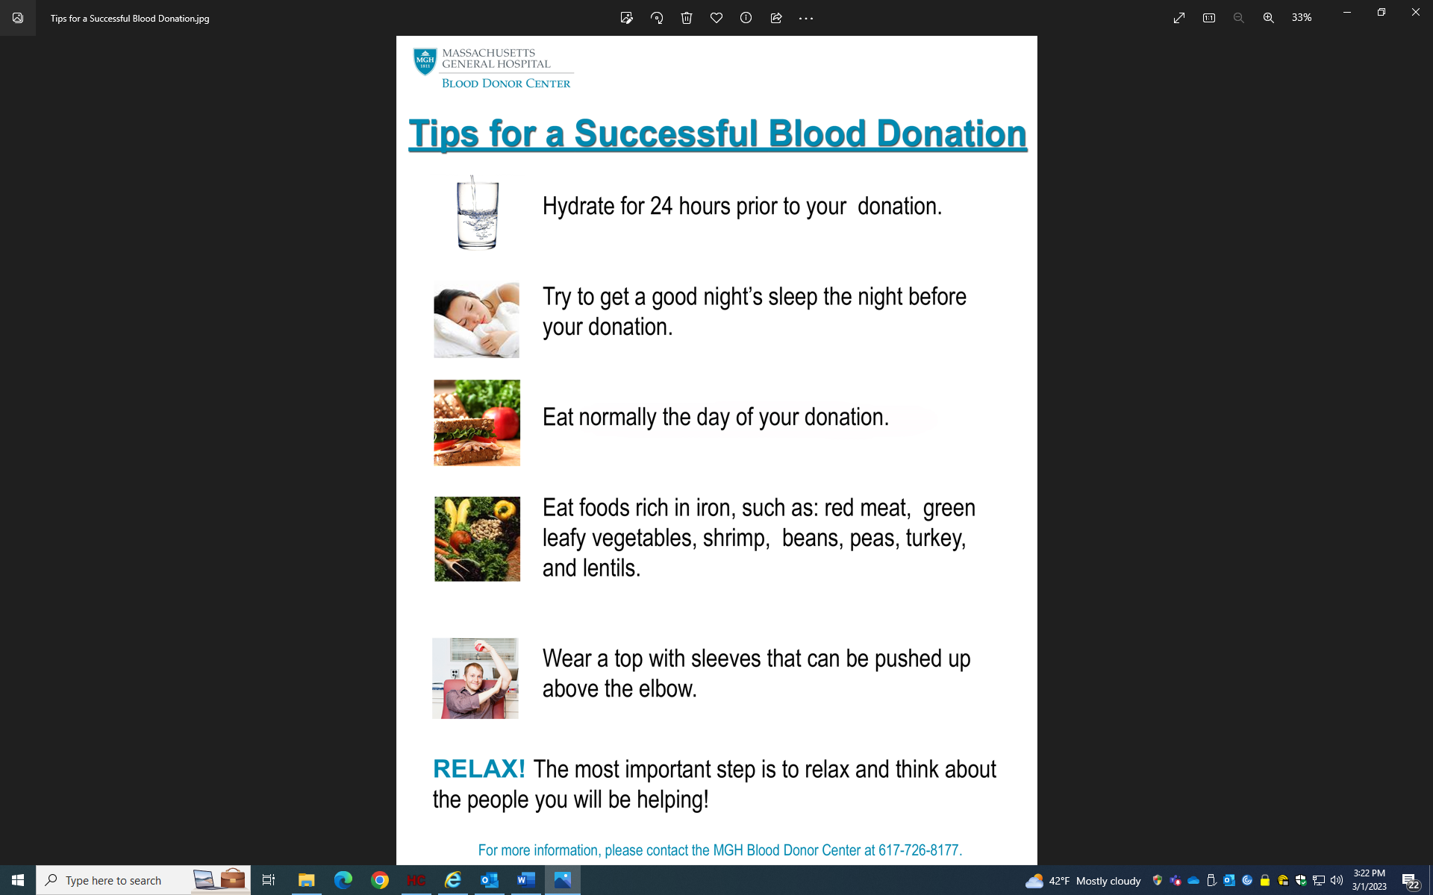

**All donors must present a photo ID!**

