Tips for a Successful Blood Donation
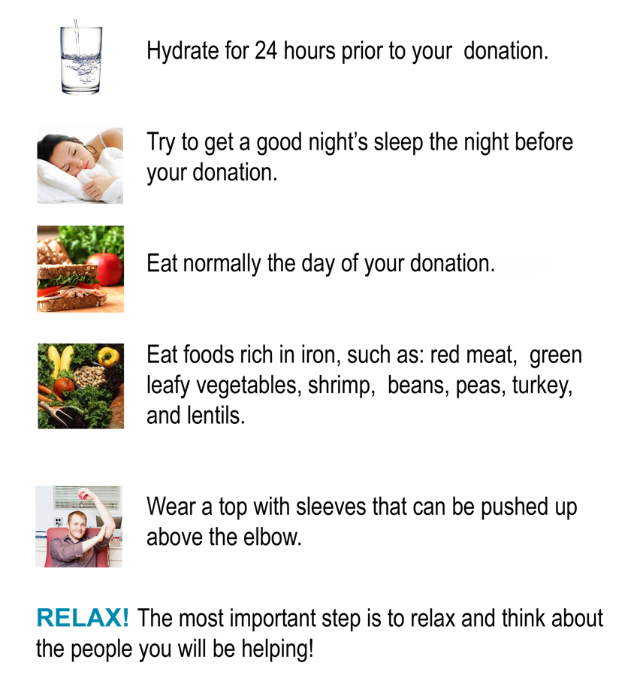
All donors must present a photo ID!


