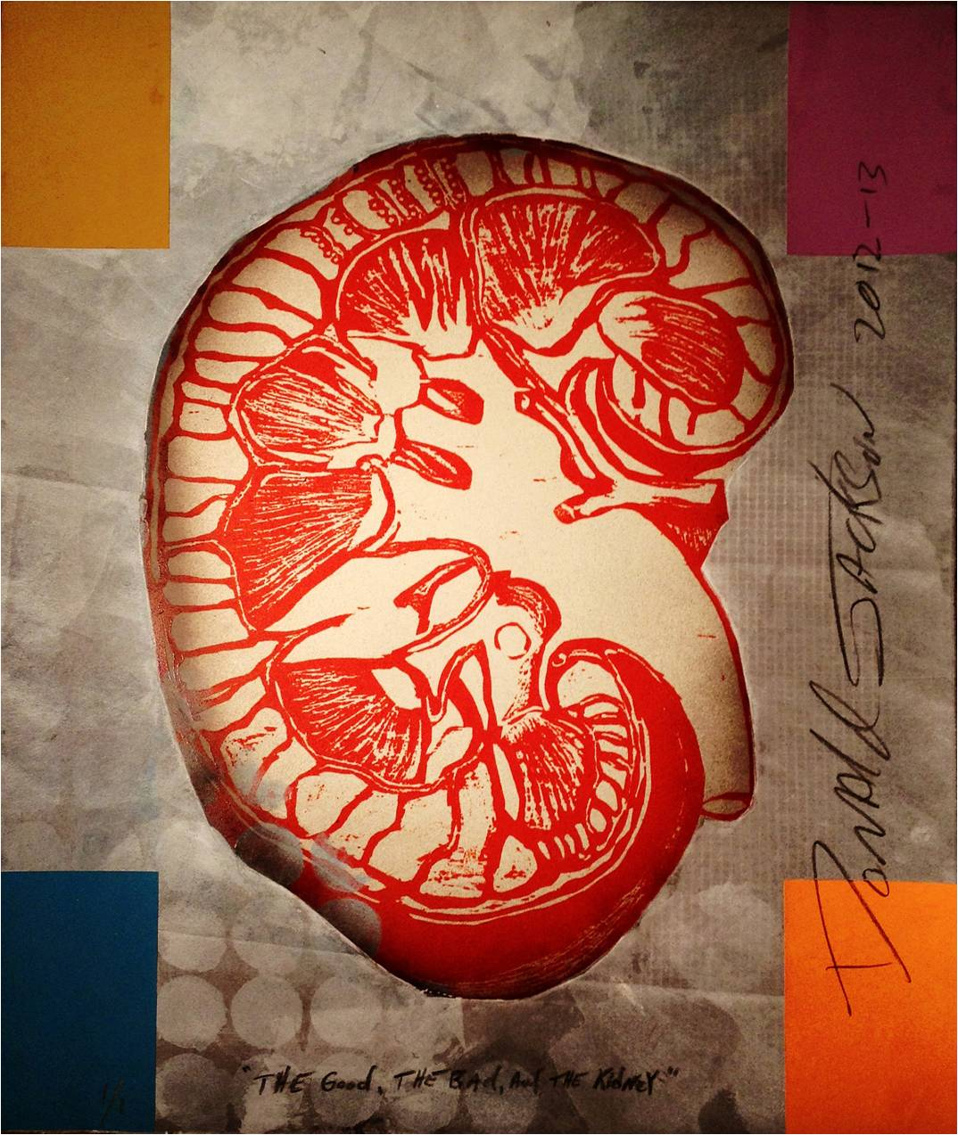
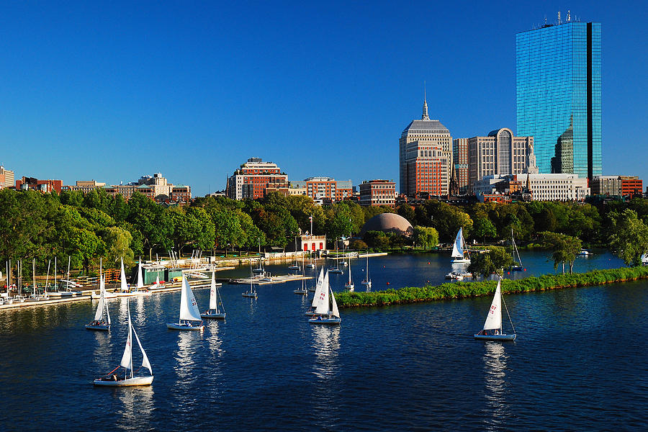
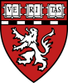
HARVARD UNDERGRAUATE SUMMER RESEARCH PROGRAM IN KIDNEY MEDICINE
NETWORK
Come together with peers with similar interest and build lasting relationships.

PROGRAM SPECIFICS
- The Harvard Summer Reseach Program in Kidney Medicine (HPKM) is a summer program for college undergraduates which offers 8 weeks of research, housing accommodations and $1000 stipend to participants
- Work with world class investigators at Harvard Medical School
- Experience how Kidney disease affects lives throughout unique clinical experiences
- Attend weekly core curriculum sessions which introduces normal kidney physiology and explores the challenges of altered kidney function
- Present your research at a national symposium in Nashville, TN
APPLICANT REQUIREMENTS
- Must be a US citizen or permanent resident
- Must be enrolled in an undergraduate degree program
- Must be committed to entire 8+ week program (June 1 –August 1)
- Rolling application process with deadline: April 4, 2014
Please visit http://brighamkidney.org/hskp/ for more information and application process.
Email HSKP@partners.org with any questions.
RESEARCH
Participate in cutting edge research with leading Harvard Investigators
CITY LIFE
Summer in Boston. Visit the Public Garden, Freedom Trail and the Charles Esplanade

