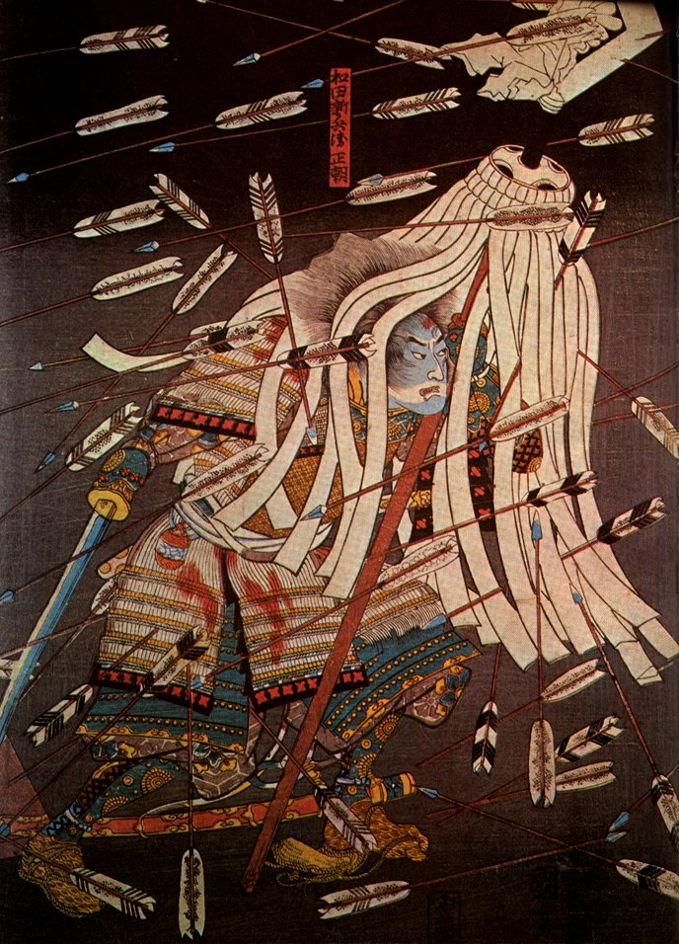

21H.154 Pre-modern Japan: Earliest Times to 1868 MW11-12.30 1-277
Surveys Japanese history from the origin myths to the fall of Tokugawa shogunate in 1868. Highlights key themes, including the rise of a court-centered state, interactions with the broader world, and the rise and fall of the warrior class. Examines the continuities as well as diversity in pre-modern Japanese culture, spirituality, and everyday life.
N. Kapur

