RESEARCH TECHNICIAN OPPORTUNITIES AT HARVARD MEDICAL SCHOOL, BRIGHAM AND WOMEN’S HOSPITAL.

Immunogenomics technician to apply high-throughput flow cytometry to explore the basis of autoimmune diseases.

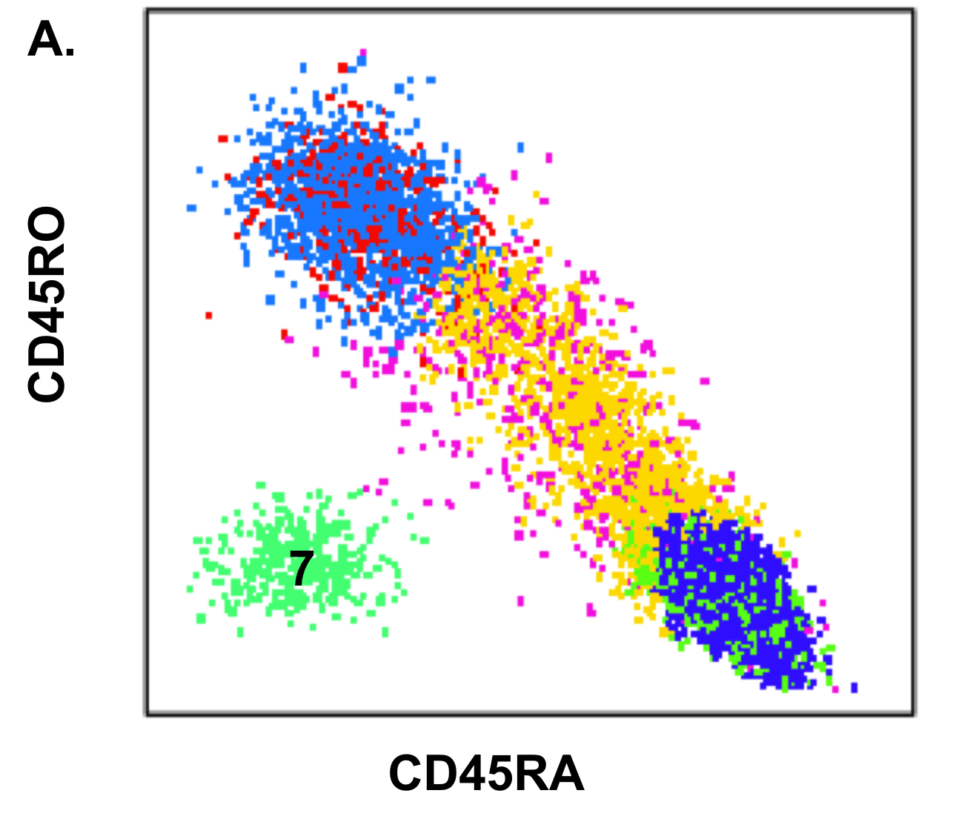
The Raychaudhuri Lab at Harvard Medical School invites applications for a research technician in immunogenomics with an interest in understanding the basis of autommune diseases. The overarching goal of the lab is to understand underlying mechanisms of autoimmune diseases. In particular, the focus of this project is to use high-throughput flow cytometry to characterize variation within the immune system using cutting-edge genetics, genomics, and cytometry. The long-range goal is to use these methods to understand the basis of autoimmune disease.


Candidates should have a bachelors degree in biological sciences. Experience working in the laboratory, particularly with immunological methods, is preferred. Familiarity with statistical data analysis is preferred. Our group is highly collaborative, working with investigators from Harvard Medical School, the Broad Institute, and Brigham and Women’s Hospital. The person hired for this position will necessarily work closely with a team of scientists of broad expertise brought together from these institutions.
Interested candidates should submit a current CV and names of three references to Dr Raychaudhuri (soumya@broadinstitute.org) directly.
Web site:
http://immunogenomics.hms.harvard.edu/index.html

