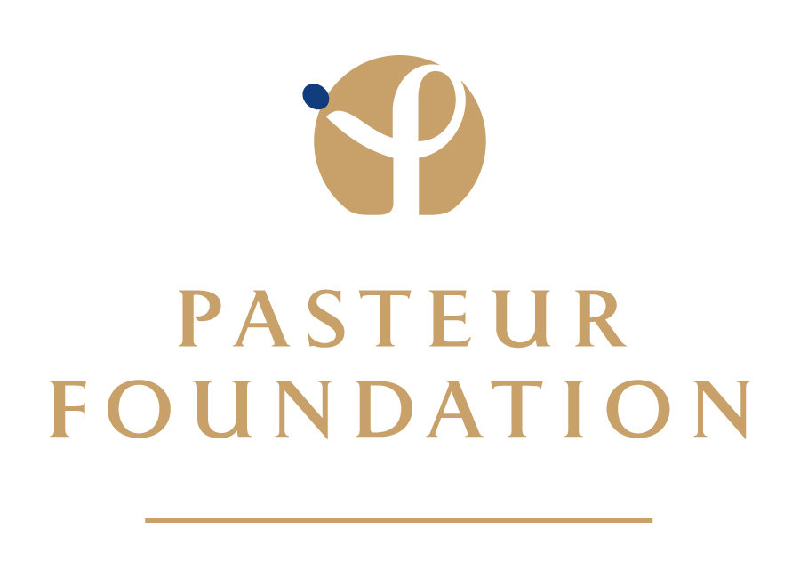



CALL FOR APPLICANTS

UNDERGRADUATE SUMMER INTERNSHIPS IN PARIS

Conduct research at the Institut Pasteur this summer!

Application deadline is Friday, December 17, 2010.

These 10-week internships at the Institut Pasteur, one of the world’s leading private, nonprofit centers for infectious disease research, offer hands-on laboratory experience to undergraduates contemplating a scientific career. Applicants must be U.S. citizens. Living allowance is $400 per week. See our website for information and downloads. summer 2011 application is now online! please check website for further information.

Application and deadline information for the Undergraduate Internship Program may be found under “Program Watch” on our homepage:

http://www.pasteurfoundation.org/

For up-to-the-minute notifications, follow us!

http://twitter.com/PasteurUS
http://www.facebook.com/PasteurFoundation
http://www.linkedin.com

