Projects In Energy

5.92J/10.191J

A project-based spring semester subject supported by The d’Arbeloff Fund for Educational Excellence And The MIT Energy Initiative

(3-2-4) Lecture TR 1-2:30pm, room 4-265; Lab Arr

Energy – where to get it from, how to use it efficiently, and how to reduce negative environmental impacts from its production, conversion, distribution and use – is arguably the most critical environmental and social challenge facing the globe today. The MIT Energy Initiative’s Education Program has embarked on an ambitious agenda aimed squarely at educating our students in the complex, transdisciplinary field of energy. One particular focus of the “Projects in Energy” subject 5.92J/10.191J is “walking the talk” on the MIT campus; improving campus energy management to increase efficiency and reduce both costs and greenhouse gas emissions. | 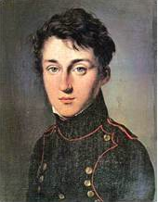  Nicolas Léonard Sadi Carnot’s Equation  $$e=1+\frac{q_{2}}{q_{1}}=1−\frac{T_{2}}{T_{1}}=\frac{T_{1}−T_{2}}{T_{1}}$$
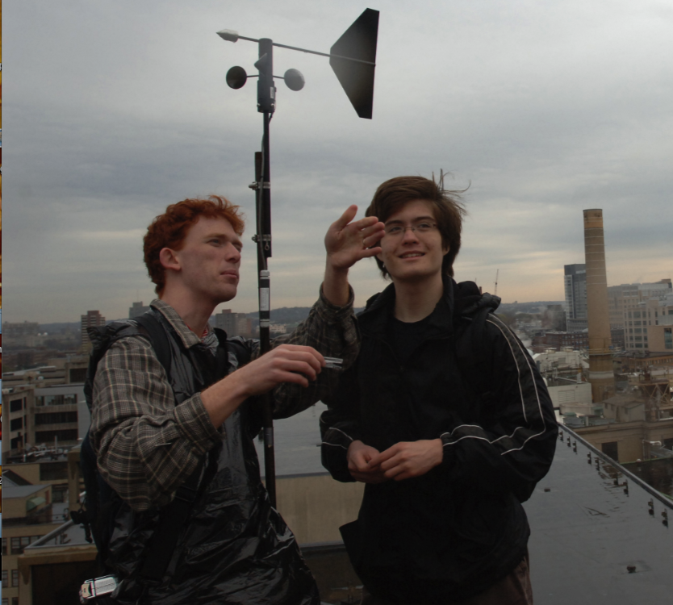  Daniel E. Wesolowski, left, fourth-year PhD student in materials science and engineering, and mechanical engineering sophomore Richard Bates check out the wind direction and speed on an MIT rooftop. Photo/Donna Coveney. | “Projects in Energy” is an entry-level subject introducing the complex, transdisciplinary topic of energy in our community and society. The class takes a project-based approach, bringing student teams together to conduct studies at MIT and in local communities. Students will develop a thorough understanding of energy systems and their major components through guest lectures by researchers from across MIT and will apply that knowledge in their projects. Students will be involved in all aspects of project design, from the refinement of problem statements to data collection and analysis, determination of conclusions and presentation of findings. Each student team will work closely with experts including local stakeholders and leading technology companies throughout the development and implementation of their projects.  The subject carries nine units and qualifies for Energy Minor elective credit.
For project updates go to: http://mit.edu/chemistry/www/academic/592J.html

For more information contact:
Prof. Jeffrey Steinfeld  Room 2-221  (617)253-4525  jisteinf@mit.edu | or Kathy Araujo  Room 9-547  kmaraujo@mit.edu

