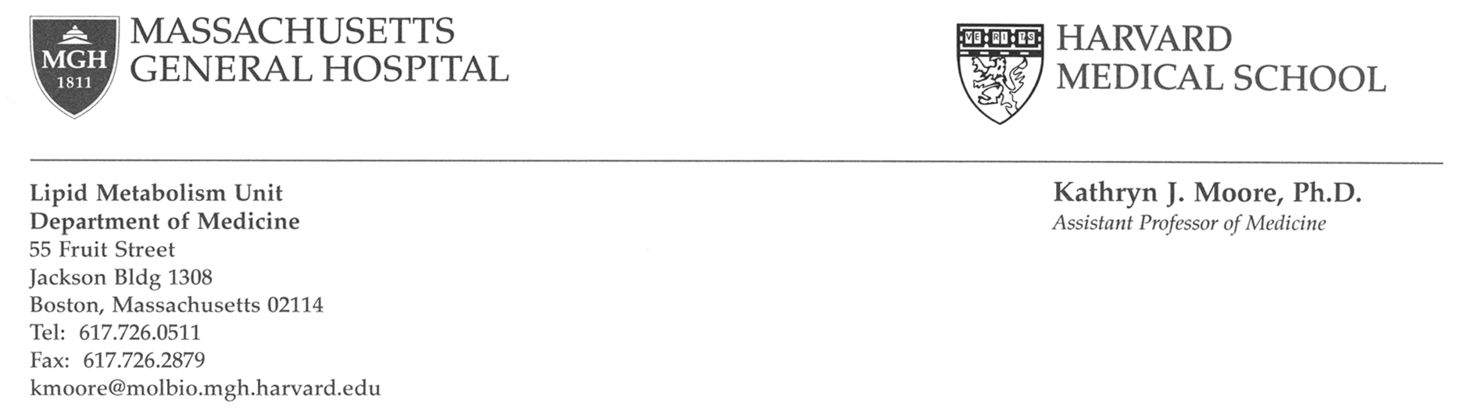

Research ASSistant Position

Full-time research assistant positions are available at Massachusetts General Hospital to study innate immune signaling pathways contributing to atherosclerosis and Alzheimer's disease. These studies focus on the signal transduction pathways regulating monocyte/microglial responses to oxidized lipoproteins and beta-amyloid, and their roles in chronic inflammation. This work involves the use of both classic molecular biology techniques (site-directed mutagenesis, cloning, gene knock-outs, gene transfer techniques) and broad-scale genomics approaches (gene expression microarrays, proteomics). Additional projects in the lab include investigation of leukocyte trafficking into tissues.

The applicant for this position should have an interest in cellular and molecular biology, and immunology. Some experience in molecular biology, cell culture and mouse handling is preferred, although not required. Interested candidates should mail, fax or e-mail resumes to:

Kathryn J. Moore, Ph.D.
Assistant Professor of Medicine
Massachusetts General Hospital / Harvard Medical School
55 Fruit Street, Jackson Bldg. Room 1328
Boston, MA 02114
Tel: 617-726-0511

Fax: 617-726-2879
Email: kmoore@molbio.mgh.harvard.edu

