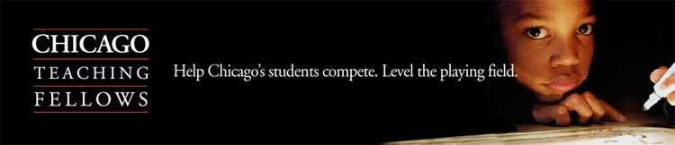

Help Chicago’s students compete. Level the playing field.

Want a job that matters?
Share your passion for math or science with the students of Chicago.

The Chicago Teaching Fellows program is seeking a select group of outstanding individuals to use their science or math skills and teach middle and high school students in Chicago Public Schools.

Even as mathematical and science skills become more and more important in a technology-oriented economy, our middle and high school students fall further behind in these studies.

Although a bachelor’s degree is required, no previous experience or coursework in education is necessary to apply.

- Chicago Teaching Fellows will begin teaching full-time in the fall of 2007 while pursuing their permanent Illinois teacher certification at a local university. Fellows will receive regular teachers’ salary and full benefits.
- Participants will benefit from a specialized paid summer training that will prepare them to be successful in urban classrooms.
- Benefits of the program include a streamlined application and selection process and the opportunity to join a cohort of like minded professionals committed to utilizing their talent in mathematics or science to ensure the children of Chicago receive a high quality education.

Chicago Teaching Fellows is now accepting applications from individuals interested in teaching science, math, Spanish, Chinese, and special education. For more information or to apply, please visit: www.chicagoteachingfellows.org.

Become a certified teacher.
Make a difference in Chicago’s classrooms.

