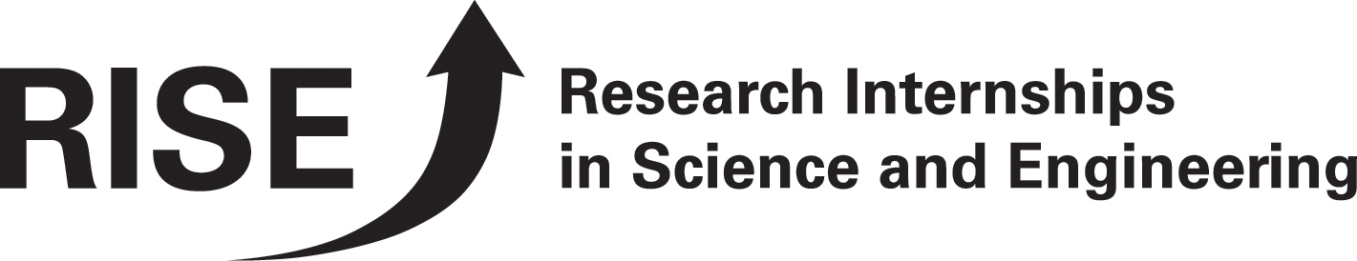RISE 2007
Good research relies on cooperation and international teamwork is integral to advancement the science and engineering fields. Scientists and engineers with international experience are increasingly sought after in both business and academia. There are limited abroad programs for undergraduates in fields of applied science and engineering. Therefore, the DAAD (German Academic Exchange Service) sets out to create unique opportunities for students at universities in the United States and Canada who are interested in gaining serious research experience in Germany.
Unique Opportunities in Gaining Research Experience in Germany
RISE - Research Internships in Science and Engineering grant students in the fields of Biology, Chemistry, Engineering, Geology and Physics the opportunity to spend a summer working with German doctoral students on serious research projects. The doctoral students help integrate the undergraduate directly into the lab work and serve as personal and professional mentors. All participants receive stipends to help cover living expenses, and the partner universities and research institutions provide housing assistance.
The Program Benefits Everyone Involved
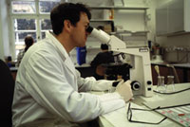
North American Undergraduate Students in science and engineering get a glimpse of advanced research work while gaining desirable practical experience in their field. They learn about Germany from an insider’s perspective: meeting new people, living abroad, taking on a new language or building upon their existing German language skills. Long-lasting friendships are born from these intensive work environments but are balanced with fun evenings or weekends out with colleagues.

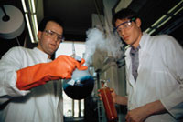
German PhD Students receive much-needed assistance with their research projects. They profit both professionally and personally from contact with the RISE students, by increasing their knowledge of the culture, lifestyle, and higher education systems in North America. The project also offers doctoral students an excellent opportunity to gain subject-specific English language knowledge.
Learning From Each Other
Beyond matching interns to be undergraduate research assistants for PhD students, DAAD also invites all fellows to a three-day event during the summer where they have an opportunity to learn from each others experiences while exploring a historic city and a modern German multinational corporation.
Program Support
RISE is supported with a generous grant from the European Recovery Program (ERP) of the Federal Ministry for Economics and Technology. Large industry organizations in Canada, Germany, and the US also support the program. Sponsors, including the German Chemical Industry Fund (FCI), help build ties to industry and finance additional fellowships. We thank all of our supporters for their generous support.

Interested? Want to learn more? Check out our website www.daad.de/rise
Or contact us directly: rise@daad.de

Deadlines:
German PhD students: from 1st of October to 30th of November 2006

North American students: from 7th of December to 31st of January 2007

