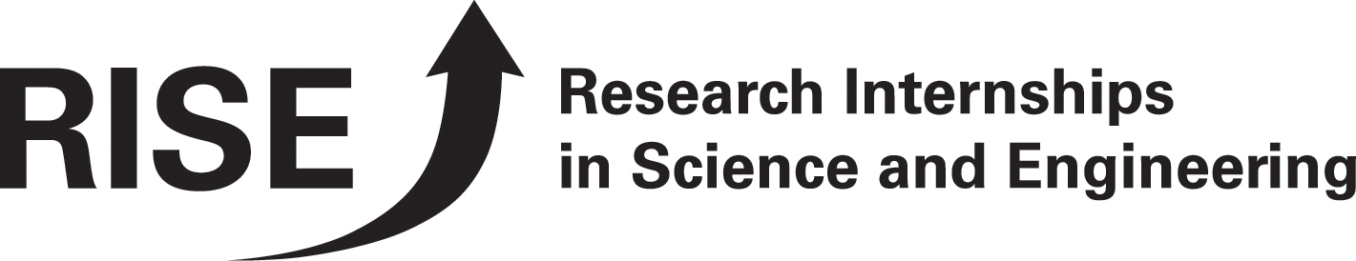Testimonials from Former RISE Participants

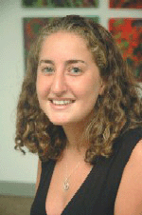Marissa Blanco
RISE Fellow 2006;DAAD Young Ambassador 2006-7
Senior at Yale University
Studying Biology & Evolutionary Biology
blanco@daad.org
“I applied to DAAD?s Research Internships in Science & Engineering(RISE) program because I wanted a chance to study abroad in Europe, which can be hard as a science major. I spent the summer as an intern at the University of Heidelberg working at the Institute for Sport and Sport Science. “

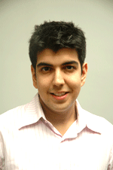
Farouk Meralli
RISE Fellow 2006;DAAD Young Ambassador 2006-07
Sernior at McGill University
Studying Anatomy and Cell Biology, International Development Studies, German Studies
meralli@daad.org
“In the summer of 2006, I had the opportunity to carry out research at the Max Planck Institute for Medical Research in Heidelberg. The opportunity to be part of such a vibrant and innovative scientific research community was made possible by the DAAD’s Research Internships in Science and Engineering (RISE) program. This experience allowed me to live and work in one of the most beautiful towns in Germany while giving me the freedom to travel throughout Europe.”


Katherine Zodrow
Rice University
Studied Water Supply Engineering in Dresden
“The work was good, challenging, and hard at times. My supervisor gave me a lot of responsibility; sometimes it felt like too much, but, for the most part, it provided me with a wonderful opportunity to see what I am capable of.”

Testimonials from Former RISE Participants

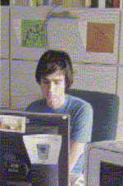
Tony Salvucci from the University of Arizona
Studied Molecular Modeling in Berlin
“I worked at GKSS research center in the molecular modeling division under the guidance of my PhD Student in Teltow. I assisted the research through an assortment of different tasks, including data entry/interpretation and various lab experiments but the most time consuming, yet fruitful, part of internship was the molecular modeling aspect. The work was very technical and sometime time-consuming, but I have no doubt that the experience I gained will be extremely beneficial to whatever career path I choose. In fact, some of the work done has already resulted in a contribution to a scientific paper that is in preparation for publication.”

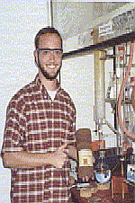
Timothy Kucharski
University of Alabama
Studied Organic Chemistry in Giessen
“The most useful aspect of the program as a whole was the experience of traveling abroad for an extended period and interacting with the people with whom I worked. This was a very enlightening experience, and it changed the way I look at the world in a way that would have not been possible by staying in the US. Furthermore, not only was I able to accomplish some great chemistry in the lab, but I was also able to make friends and connections with other chemists at Justus-Liebig-Universtat GieBen. Not only are such connections the key to forming relationships with other scientists that can lead to great results through future collaborations, but they are the important in general: They are they way we build upon the international community of scholars.”

