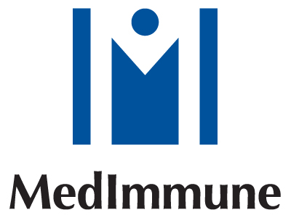

Internship

An exciting full time cell biology internship position available in cell line development lab at Medimmune, Inc, Gaithersburg, Maryland.

Position description : cell cloning, cell line adaptation, selection and characterization; cell metabolic and stability assays; recombinant protein expression .

Qualification: B.S. and M.S. student, or graduate in cell/molecular biology , microbiology, biochemical engineering or related field. 0-1 year work experience in cell biology or cell culture.

Start Date: any time during Summer or Fall , 2005

Duration: 2 to 4 months

Salary: highly competitive, based on qualification and work experience

Application: Please send CV to: Dr. Jianguo Yang, One Medimmune Way, Gaithersburg, MD 20878 or by email: yangj@medimmune.com

