New Course in Spring 2005!

BE.330 / 6.023 / 2.793: Fields, Forces and Flows in Biological Systems
(Undergraduate version of BE.430/6.561/2.795/10.539/HST.544)
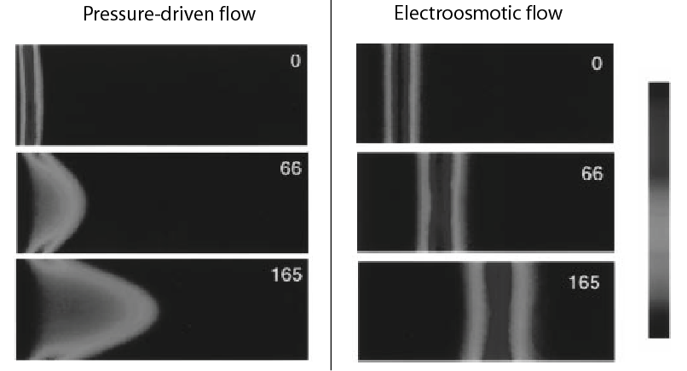
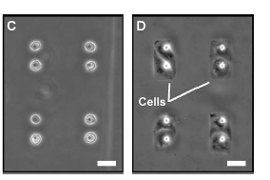
Instructors: Jay Han (jyhan@mit.edu, BE/EECS) / Roger D. Kamm (rdkamm@mit.edu, BE/ME)
Pressure-driven vs. electroosmotic flow, adapted from Paul et al. Anal. Chem. 70, 2459 (1998).
Cells trapped by dielectrophoresis, Gray et al. Biosensors and Bioelectronics 19 (2004) 1765–1774

In this course, we will introduce the basic driving forces for electric current, fluid flow, and mass transport, and discuss their application to a variety of biological systems. Basic mathematical and engineering tools will be introduced, in the context of biology and physiology. We will also discuss various electrokinetic phenomena as an example of coupled nature of chemical-electro-mechanical driving forces. Applications include transport in biological tissues and across membranes, manipulation of cells and biomolecules, and microfluidics.

The course consists of four subsections, shown as in the following.

Part I: Chemical Driving Forces
Conservation of Mass / Diffusion / Steady and Unsteady Diffusion / Diffusion with Chemical Reactions

Part II: Electrical Driving Forces
Maxwell’s equations / Ion Transport / E and B field in biological systems / Electroquasistatics /
Poisson’s and Laplace’s equation

Part III: Mechanical Driving Forces
Conservation of momentum / Inviscid and viscous flows / convective transport / Dimensional Analaysis

Part IV: Electrokinetics
Debye layer / Zeta potential / electroosmosis / electrophoresis / application of electrokinetics / dielectrophoresis / Debye layer repulsion forces / Scaling and Dimensionless numbers

Prerequisite: 6.021 or BE.320 or comparable preparation in transport with permission of instructor
Course format: 4-0-8 (12 unit, 3 lectures 10-11am MWF, 32-144, 1 recitation on Tuesday 3-4pm)
* Eligible for Engineering Concentration credit for the Course 6 (contact Jay Han for details)
* BME minor subject

