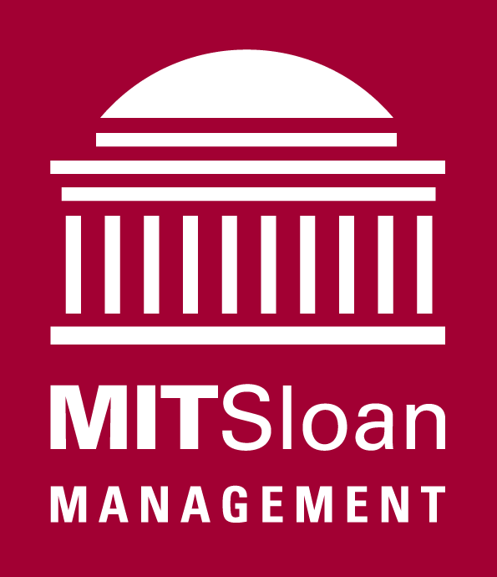

Seeking super smart Seniors interested in careers in financial services...

Come to hear about MIT Sloan’s new one year degree program -- the Master of Finance!

M.Fin. Information Session
Thursday, October 23rd
Bush Room, bldg 10-105

4:15 pm – sign in; refreshments available
4:30 pm – presentation begins
5:00 pm – Q & A

All majors are welcome.
If you plan to attend, please reply to mfin@mit.edu
Include your name, course, and year.

For information about the M.Fin. program, please visit
http://mitsloan.mit.edu/mfin/

